**ubuntu 16.04下Nginx简介（原理、安装和卸载）**

<https://blog.csdn.net/Mikeoperfect/article/details/79504426?ops_request_misc=&request_id=&biz_id=102&utm_term=ubuntu%20%E5%8E%9F%E7%90%86&utm_medium=distribute.pc_search_result.none-task-blog-2~all~sobaiduweb~default-8-79504426.pc_search_result_control_group&spm=1018.2226.3001.4187>

# <https://www.infoworld.com/article/3296360/what-is-the-jdk-introduction-to-the-java-development-kit.html>

Java EE vs spring

# Apache和Apache Tomcat的区别是什么

# 

# 

# 

# 

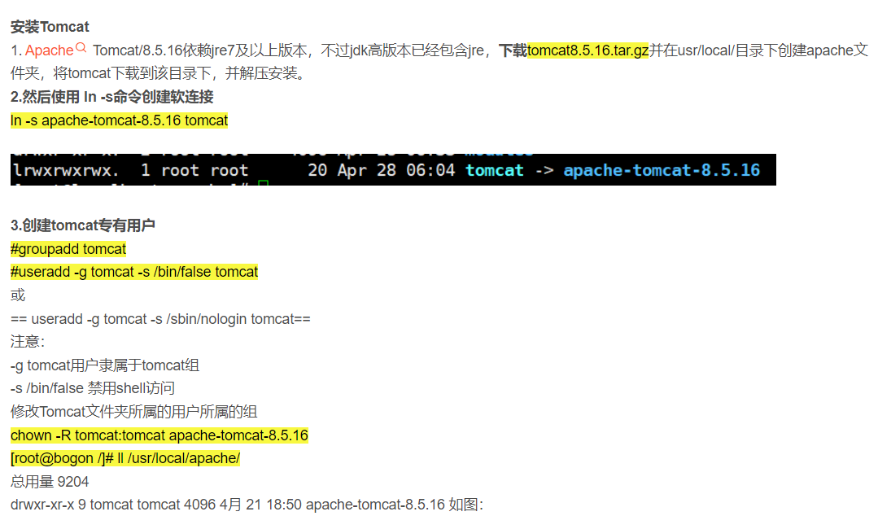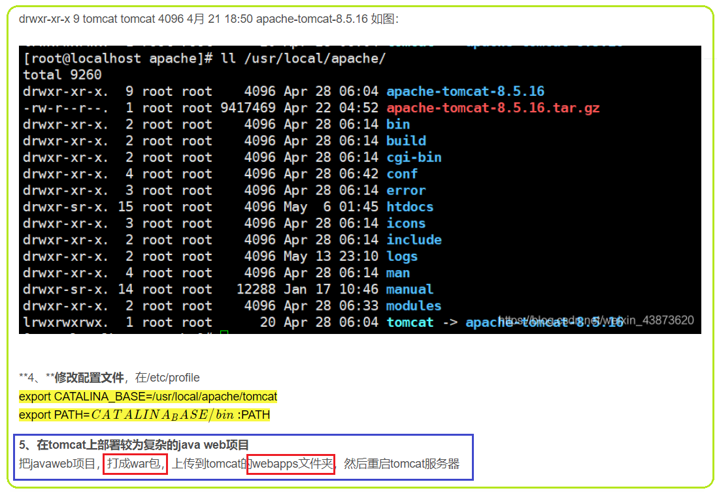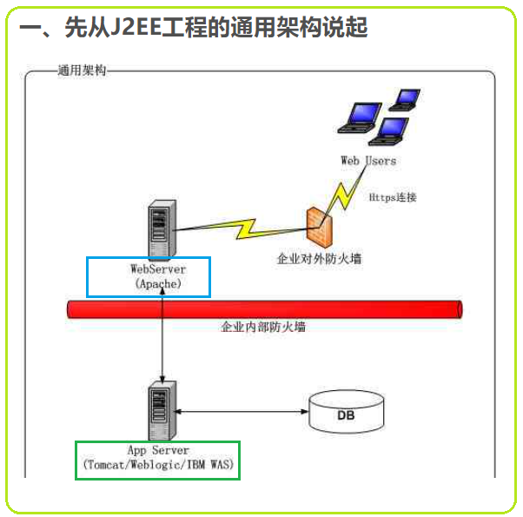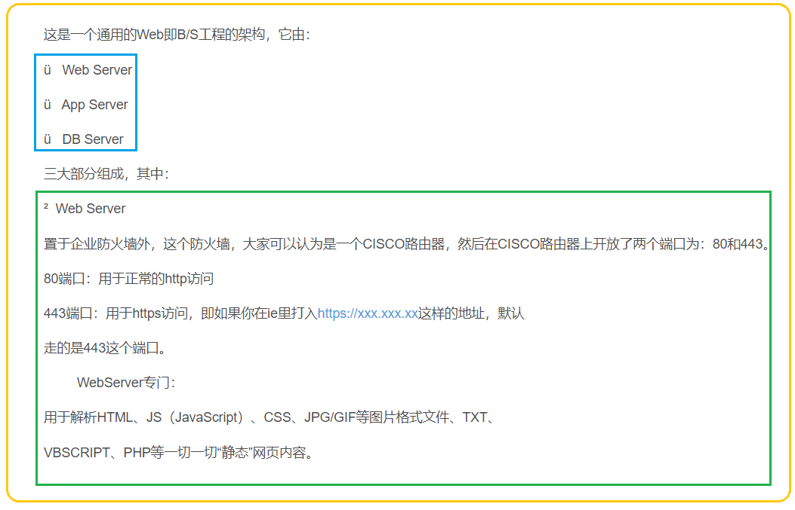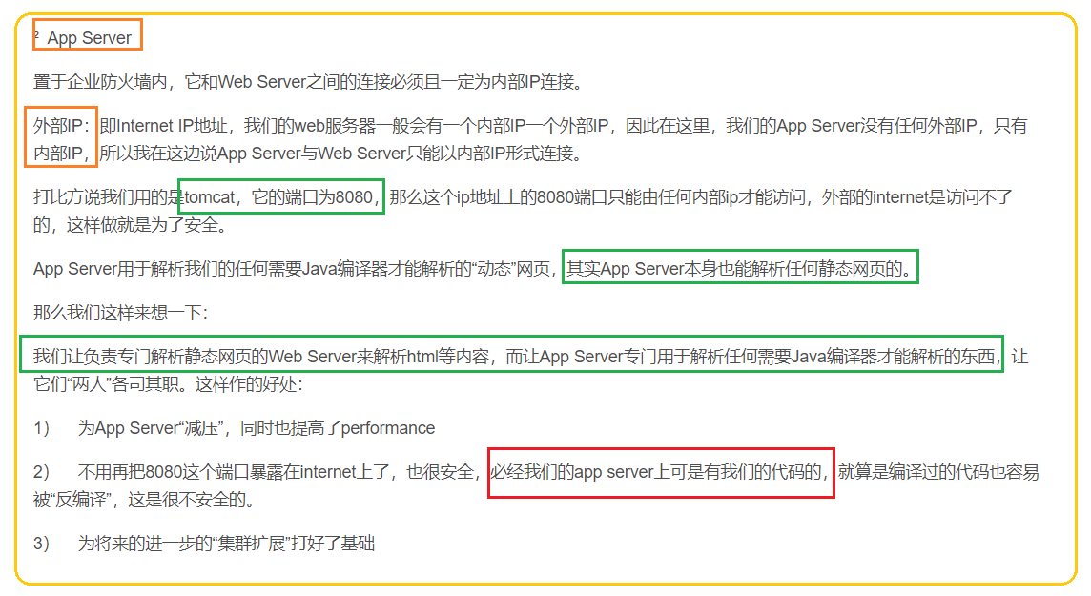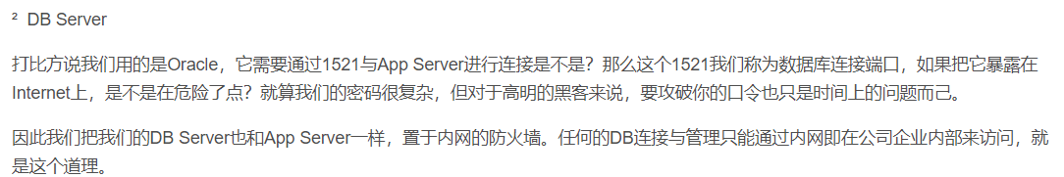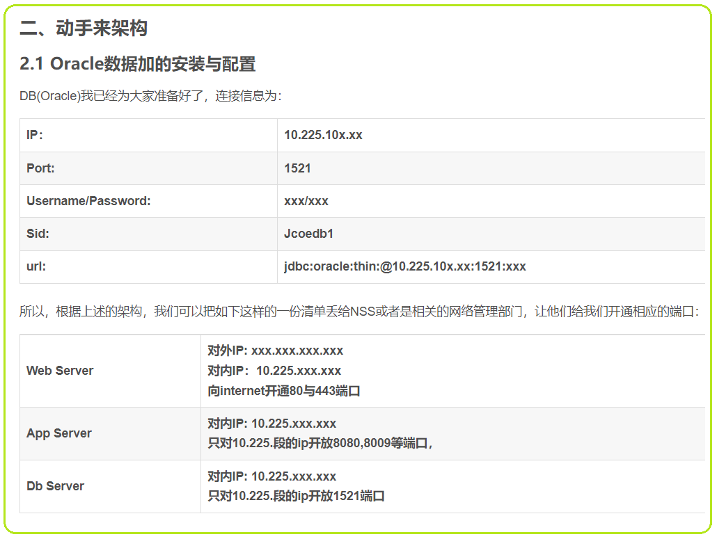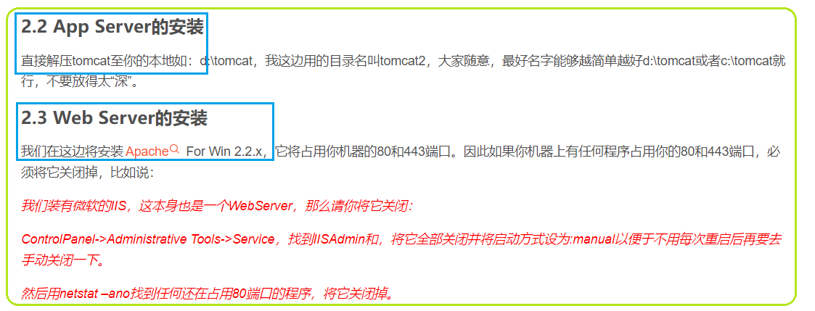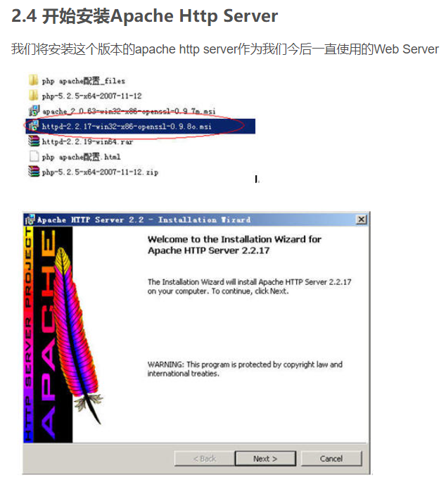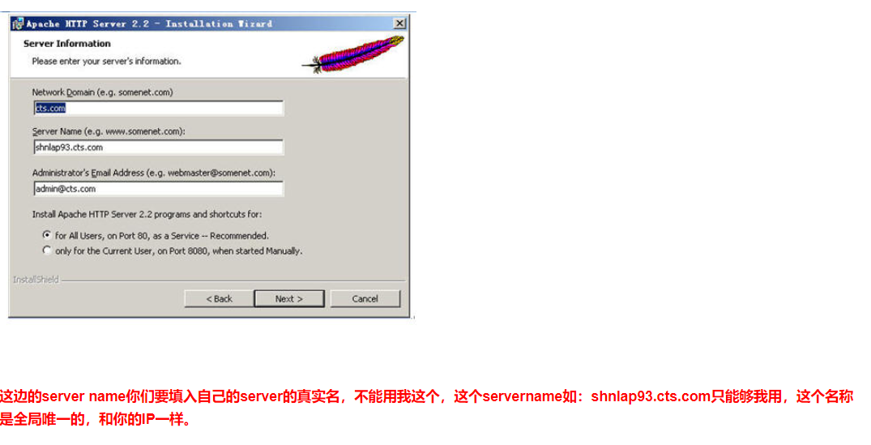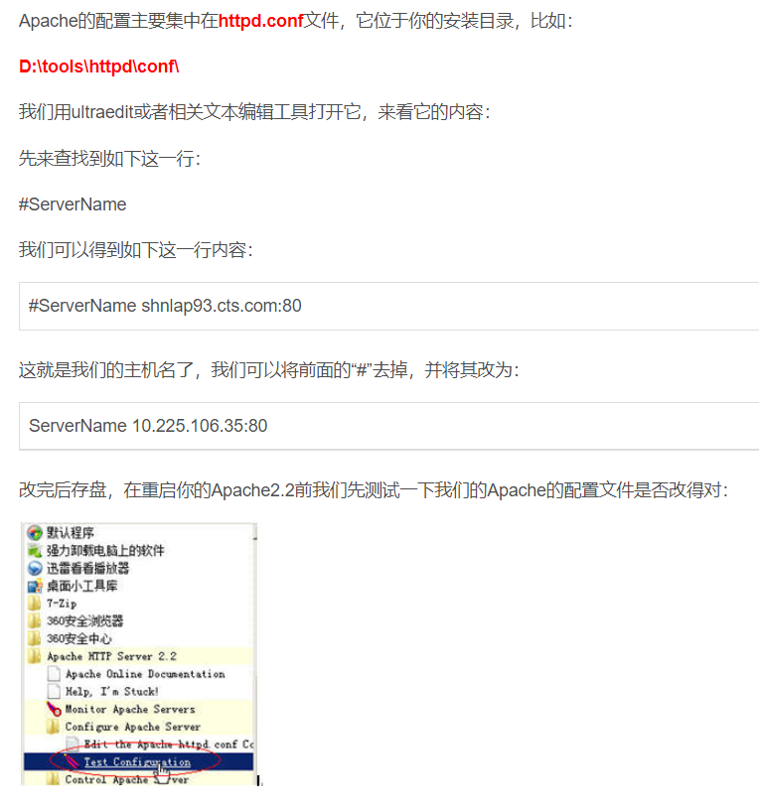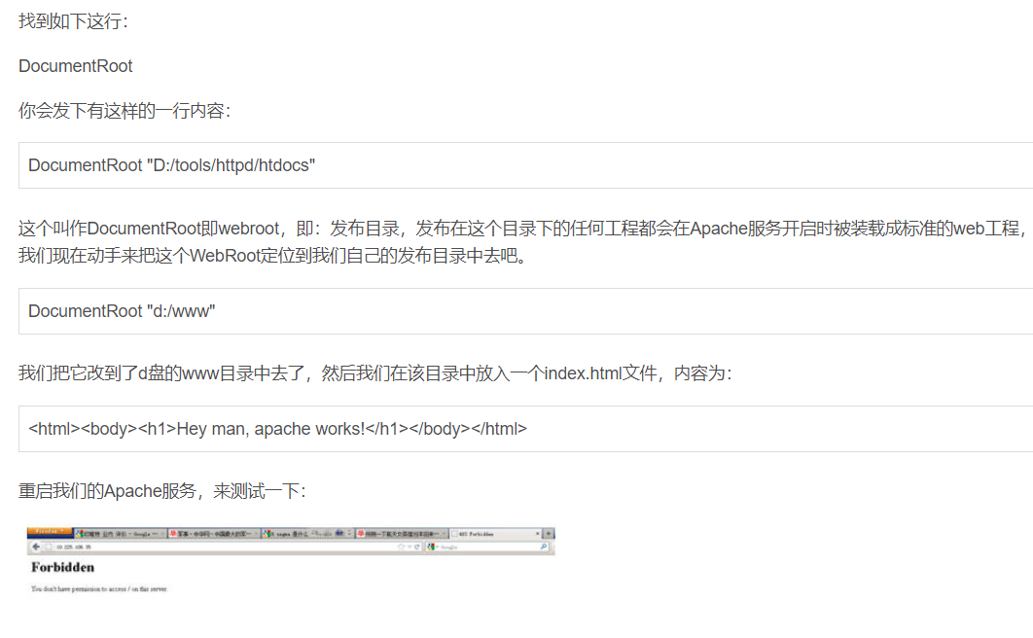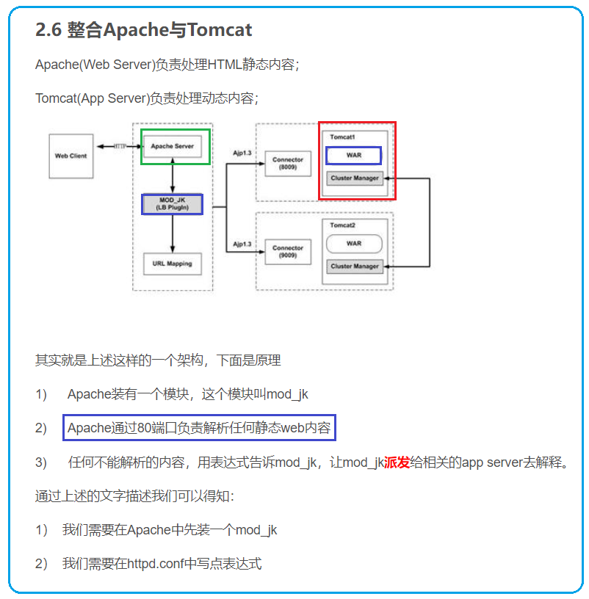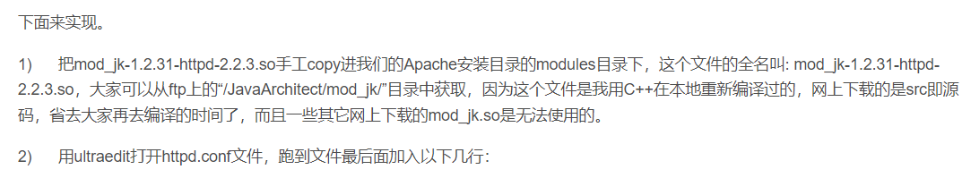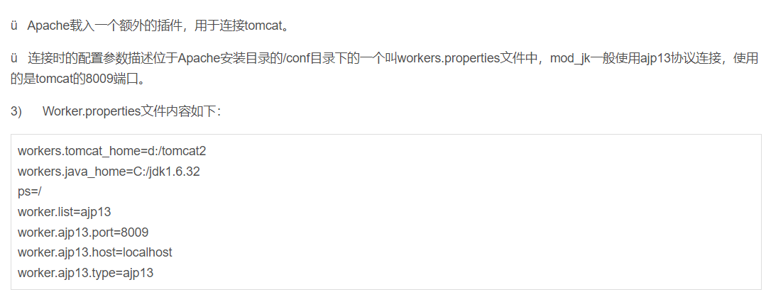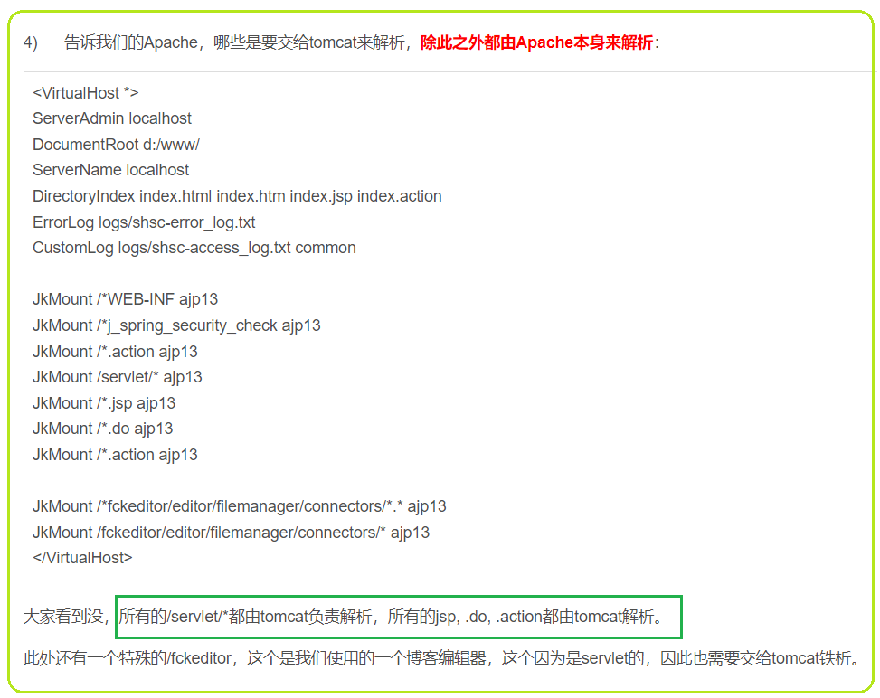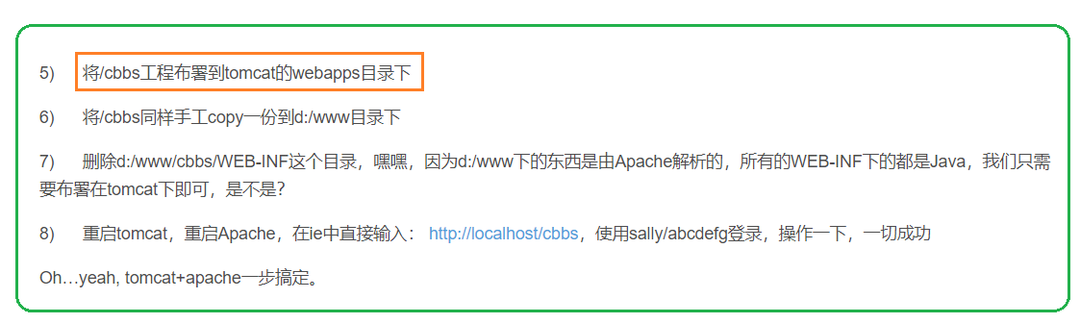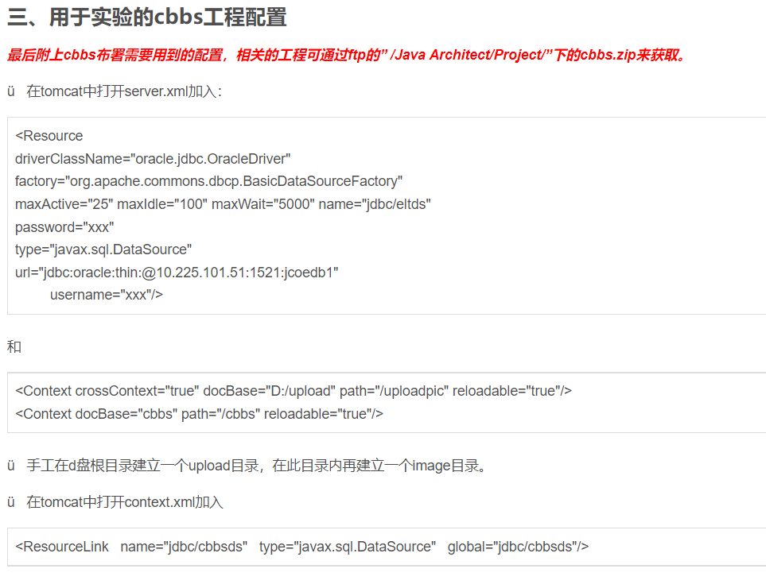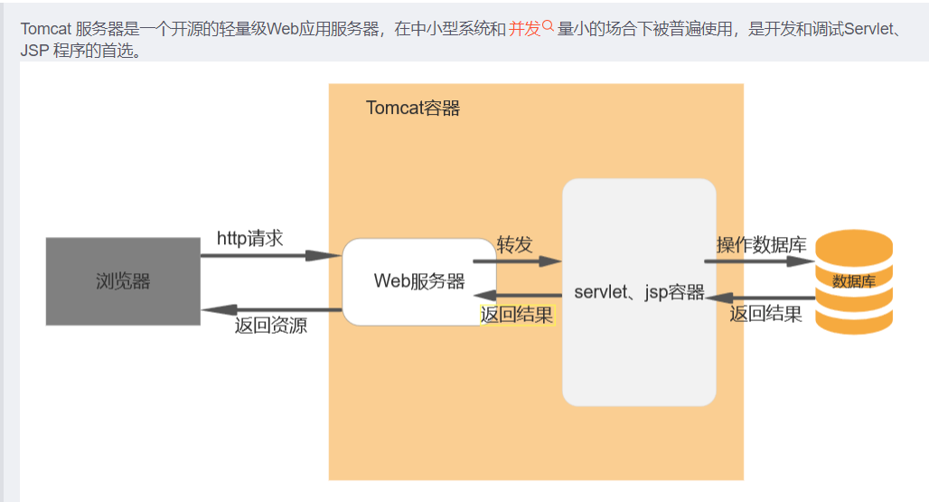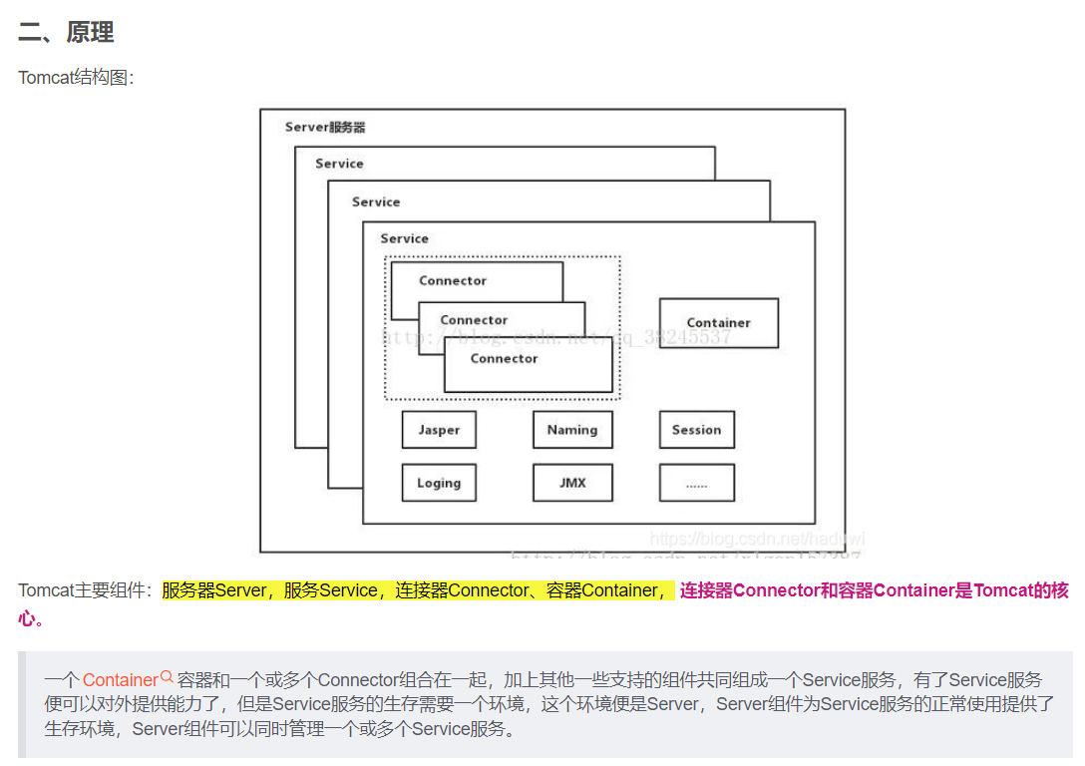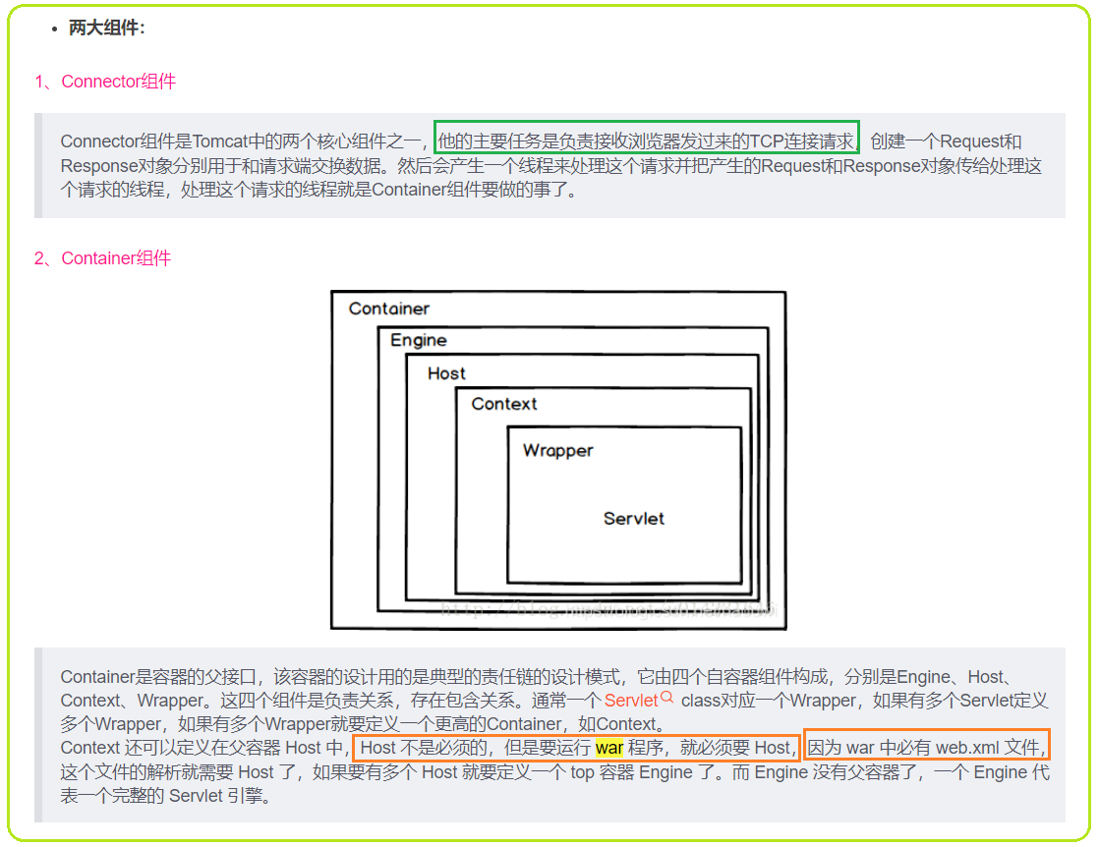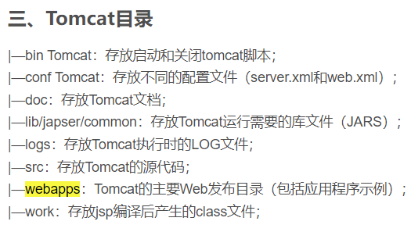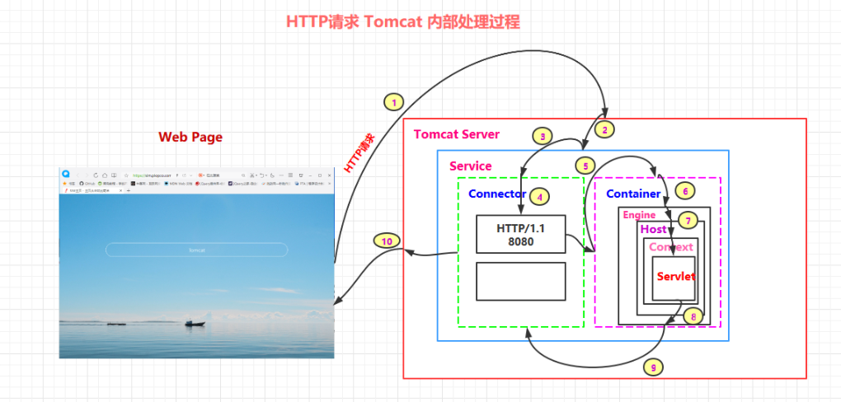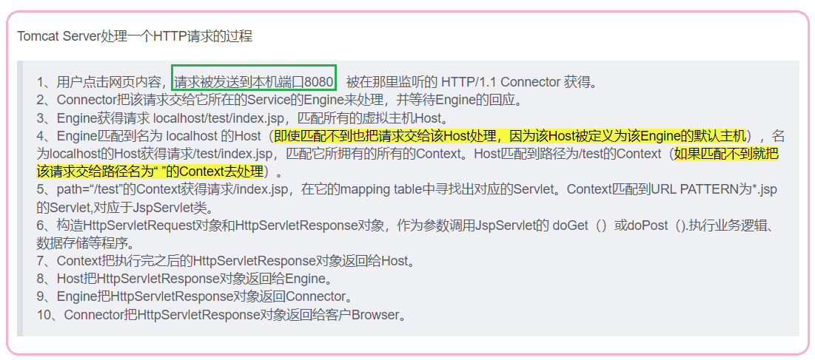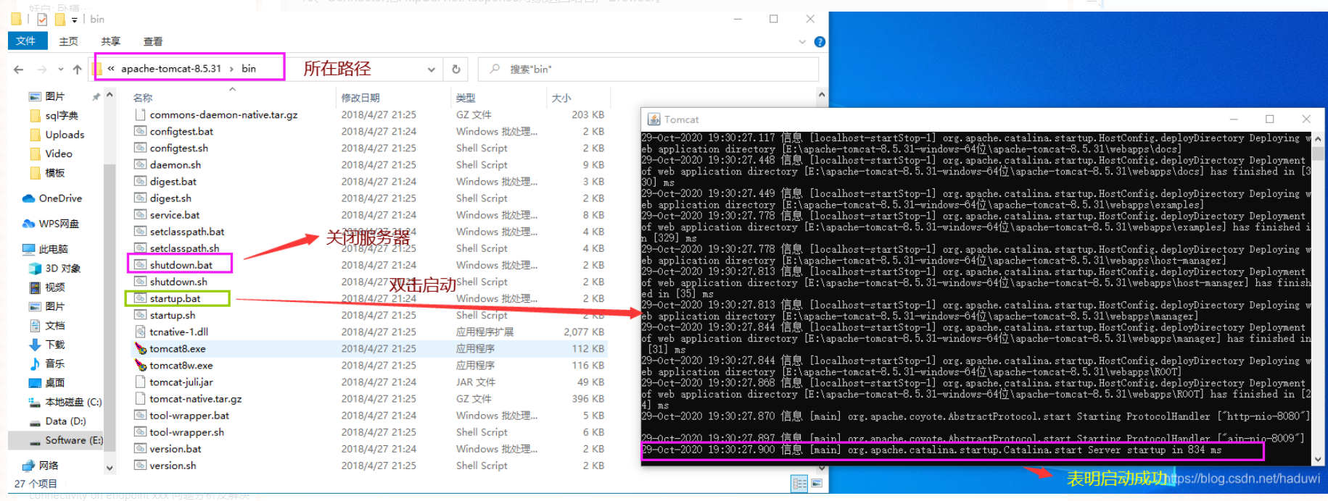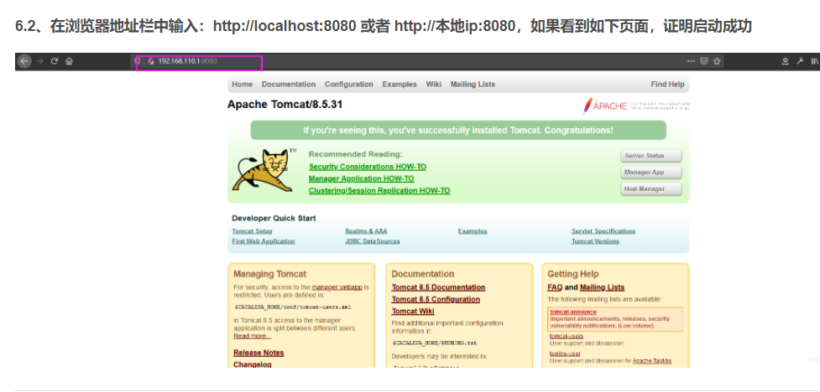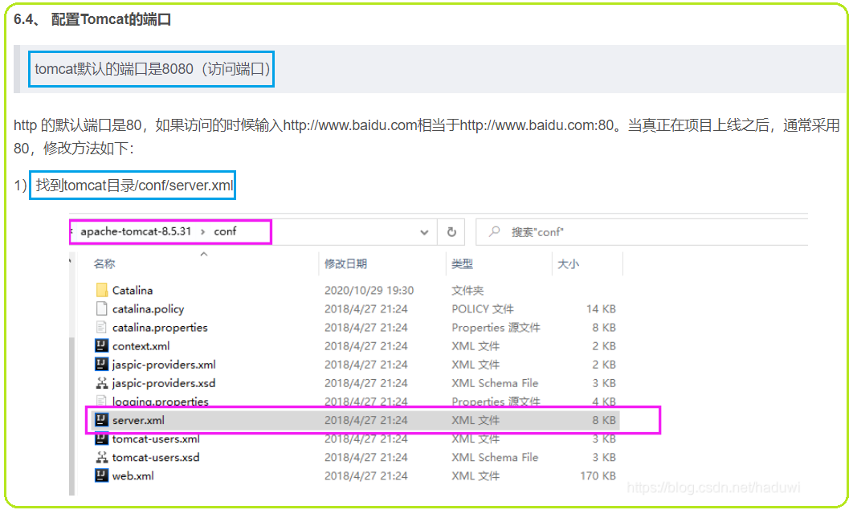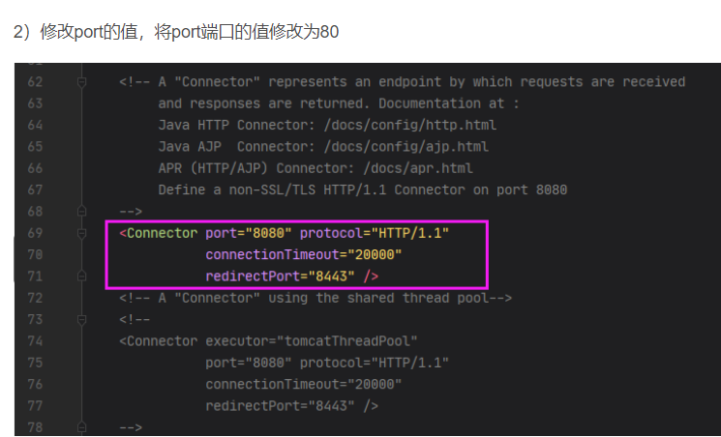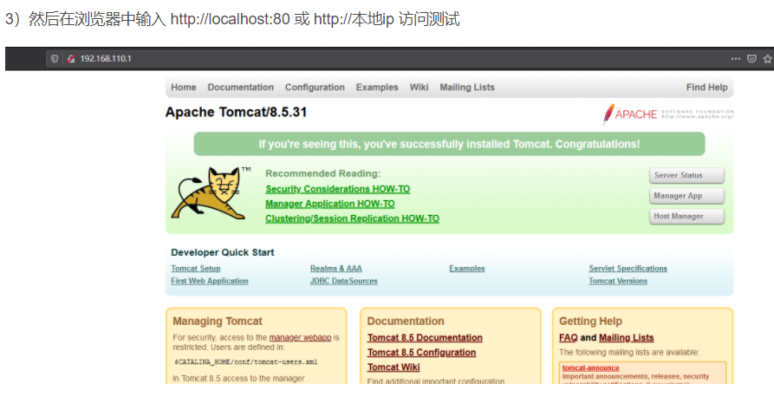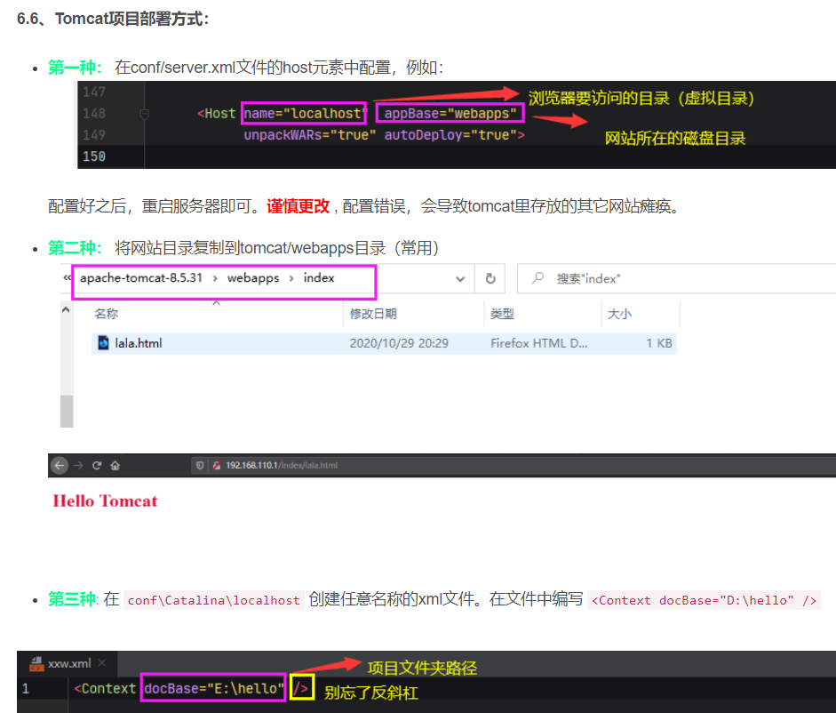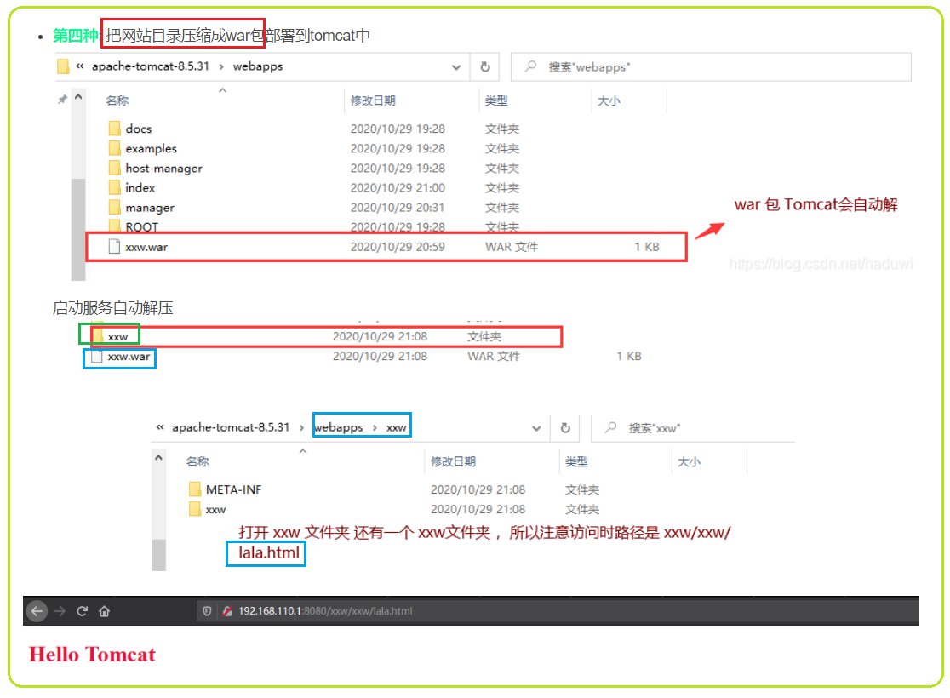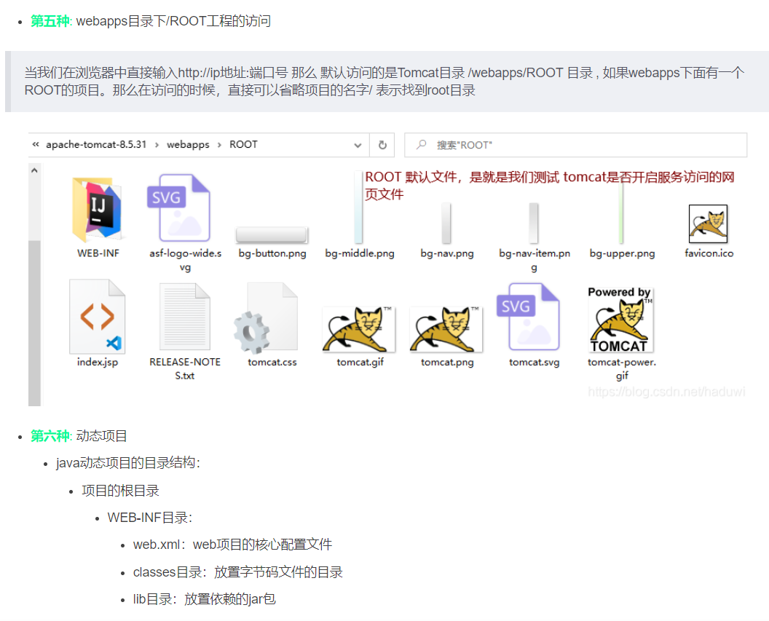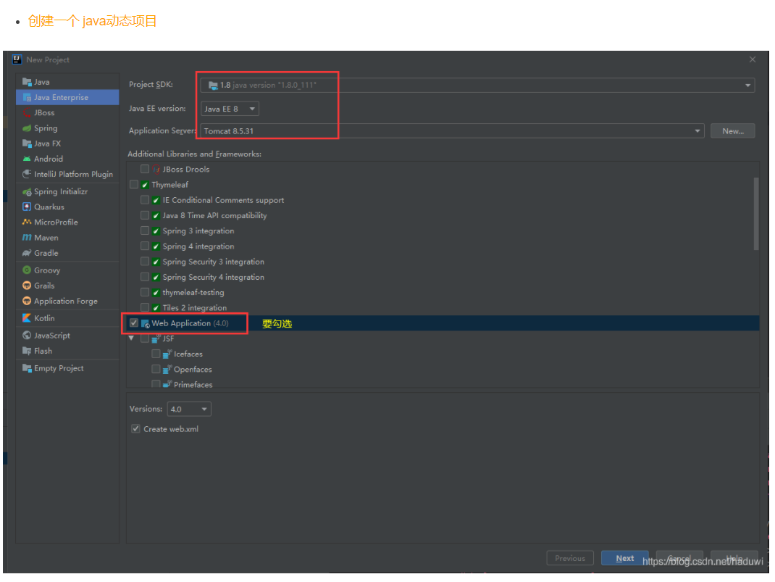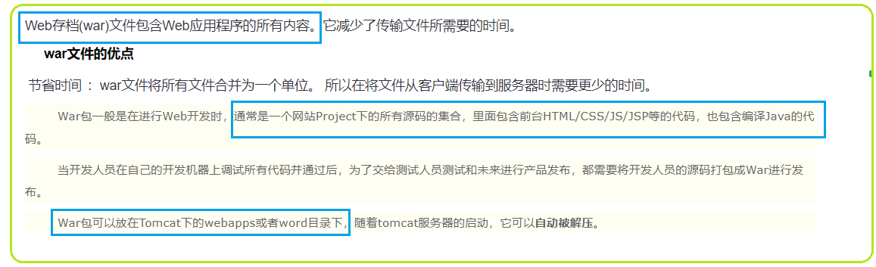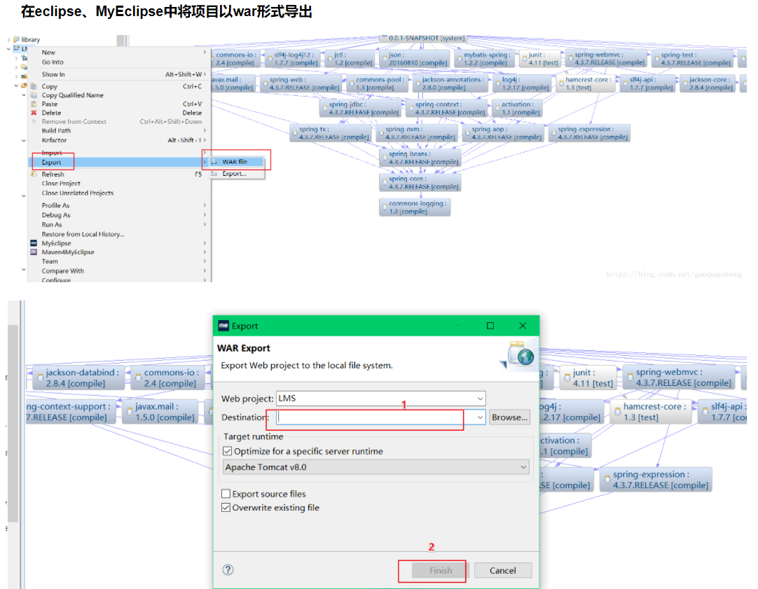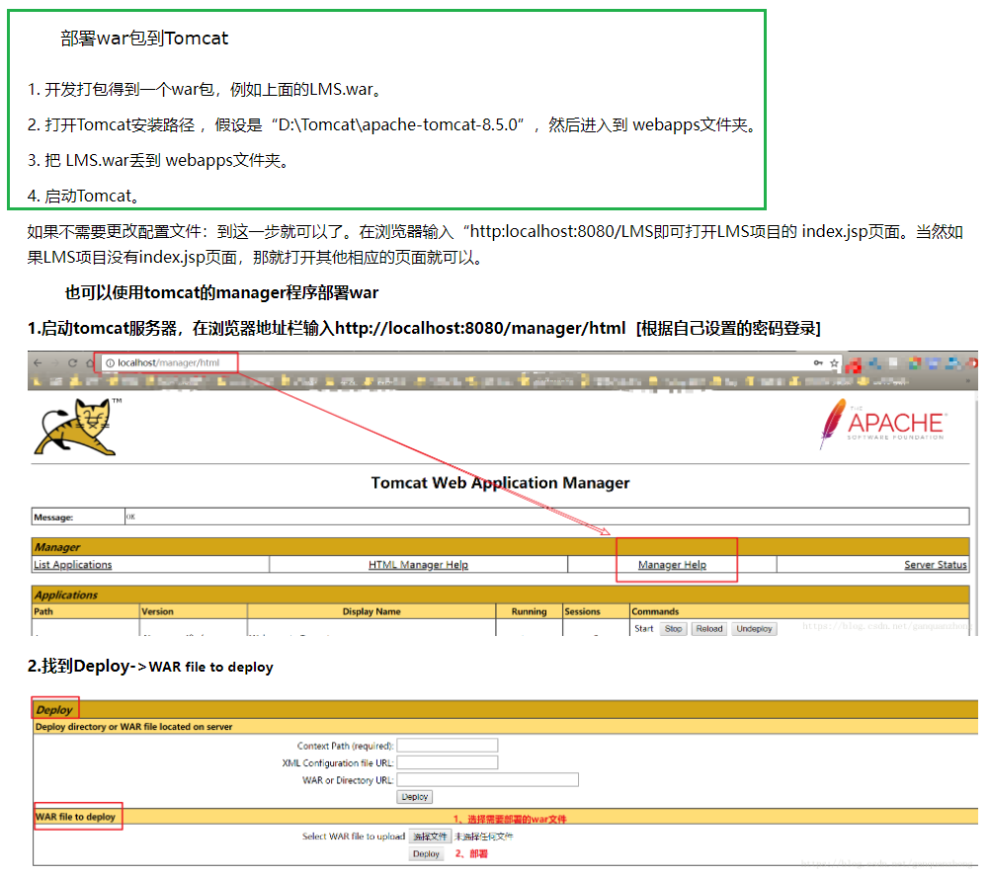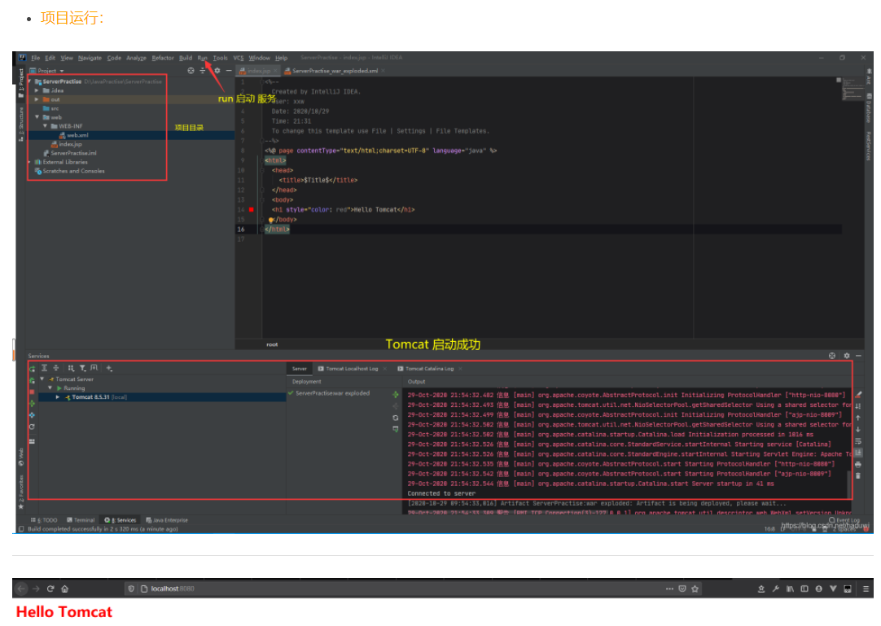

* **WAR**

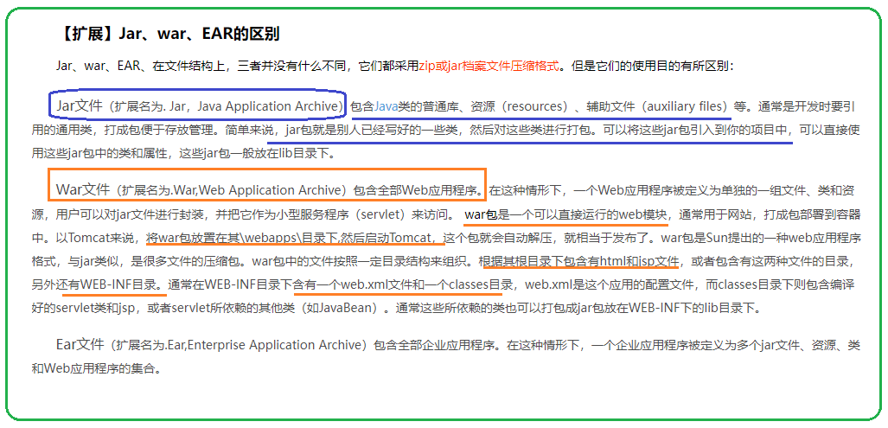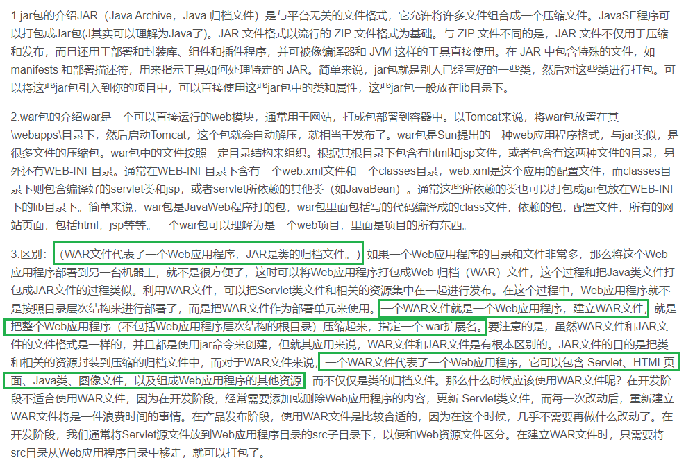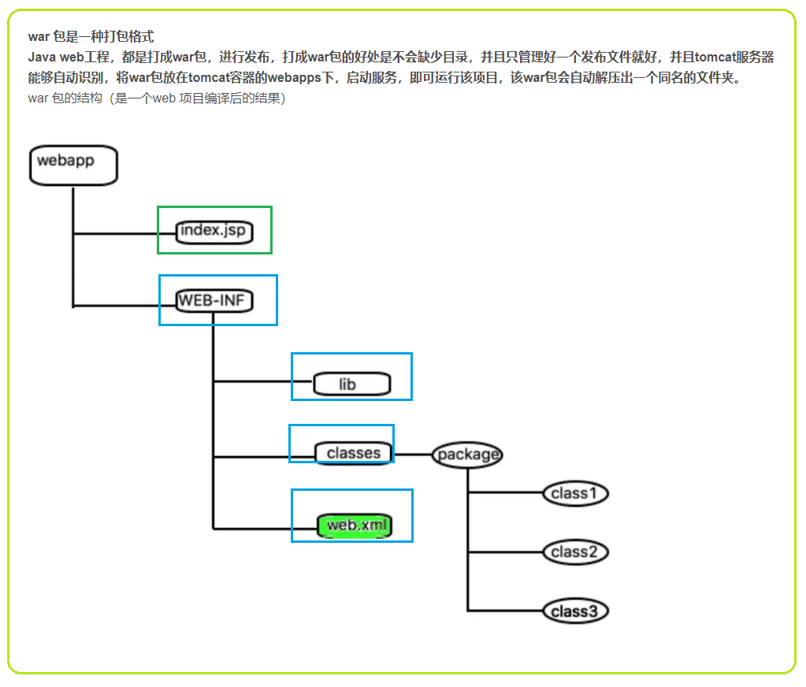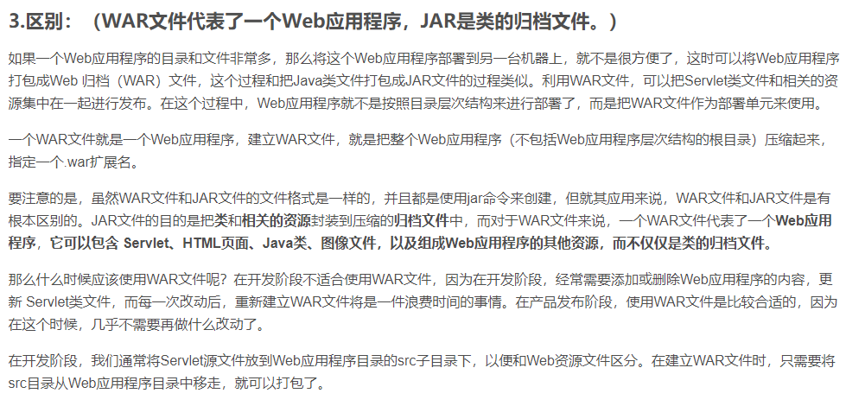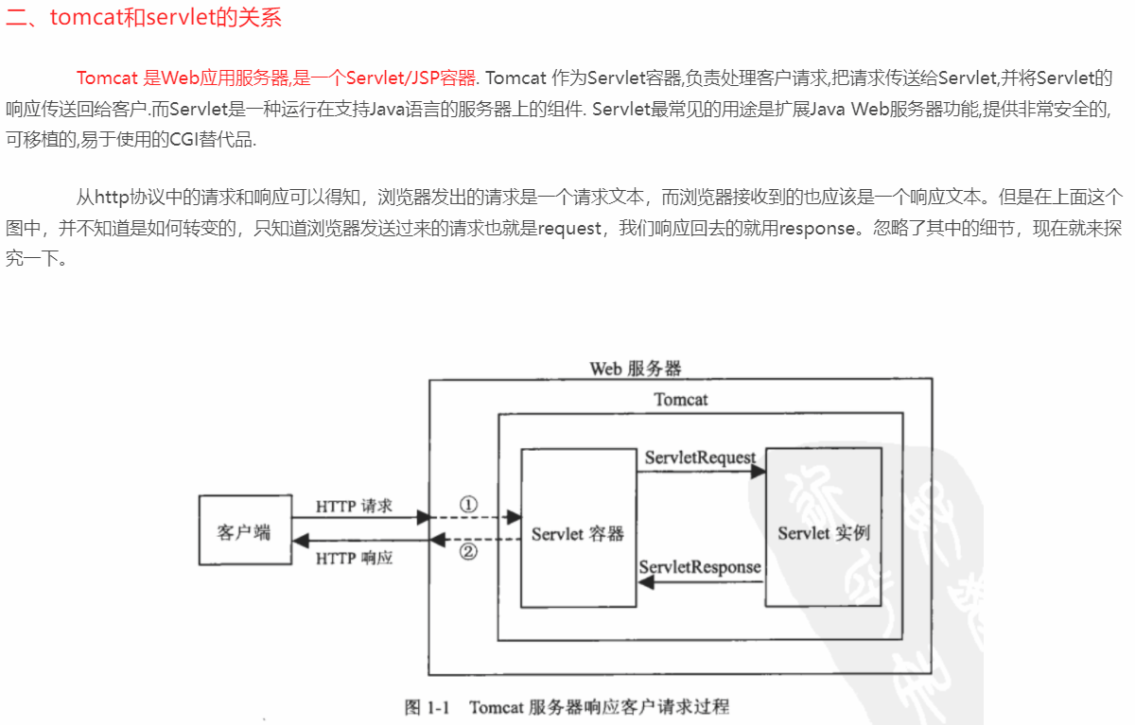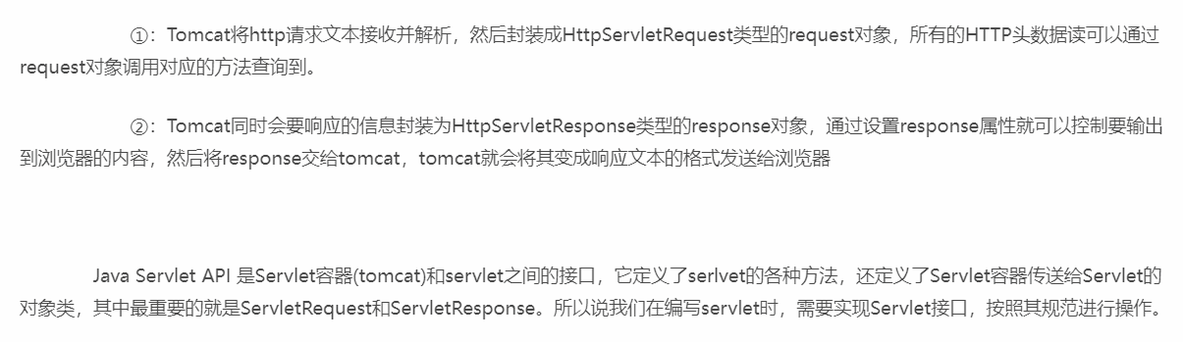https://www.cnblogs.com/whgk/p/6399262.html?tdsourcetag=s_pcqq_aiomsg

* **Servlet**

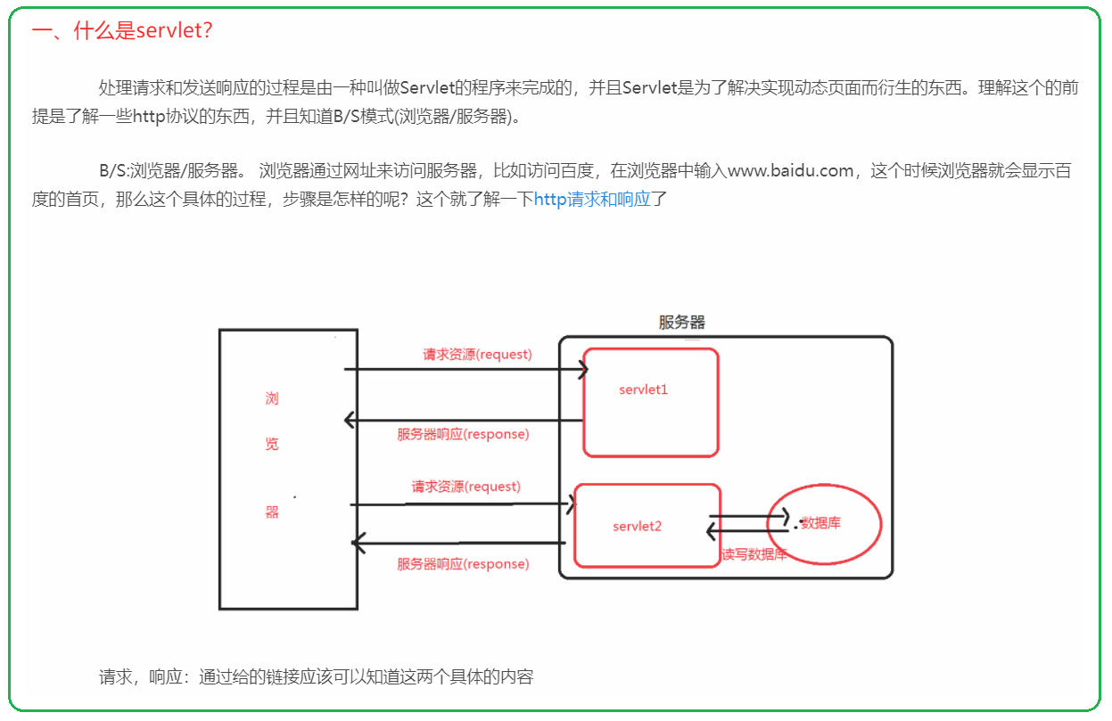

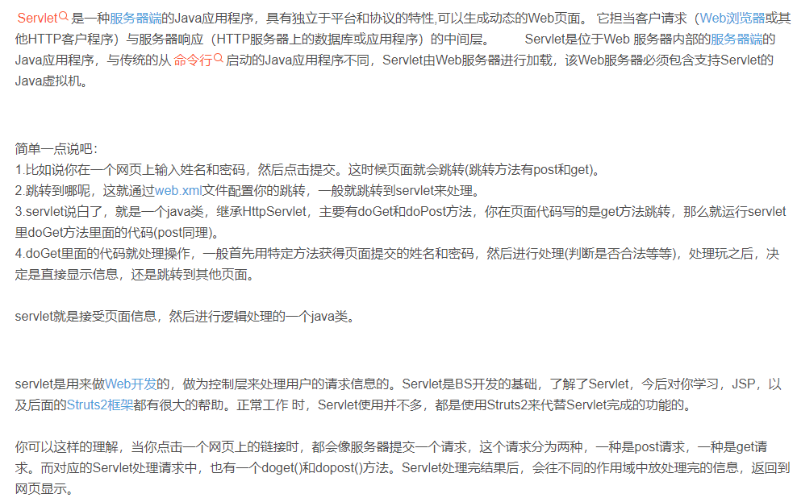

* **jsp**

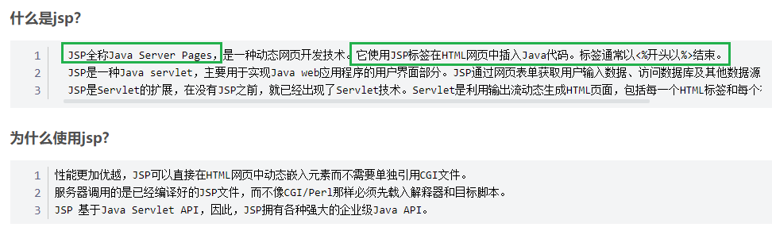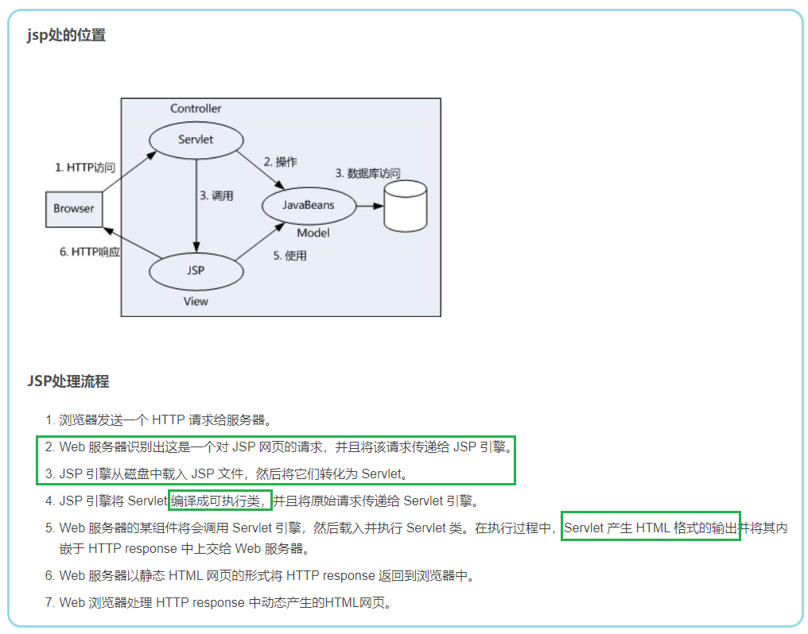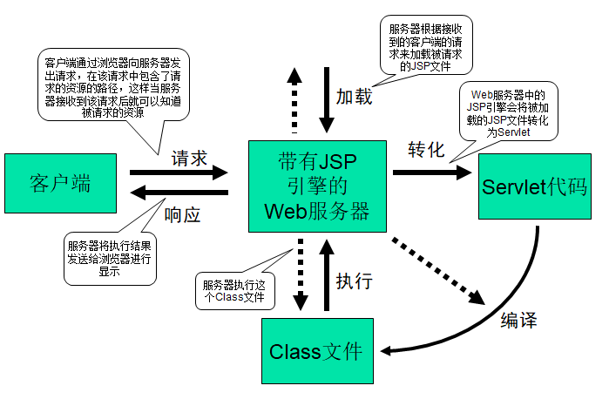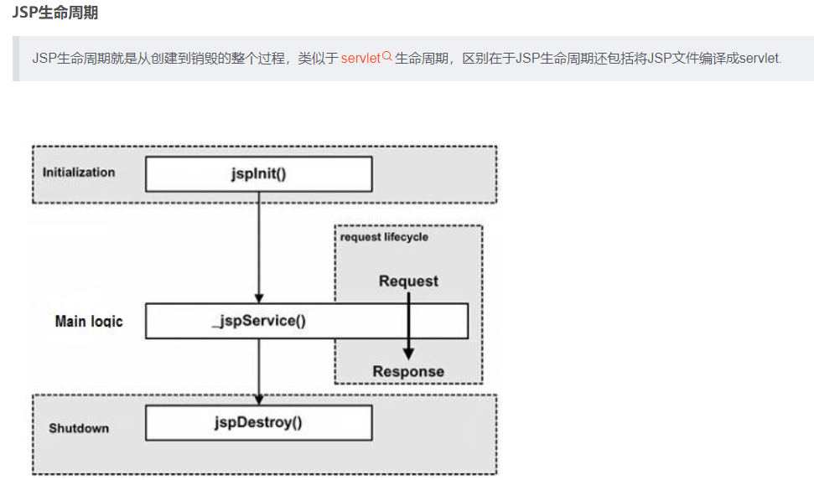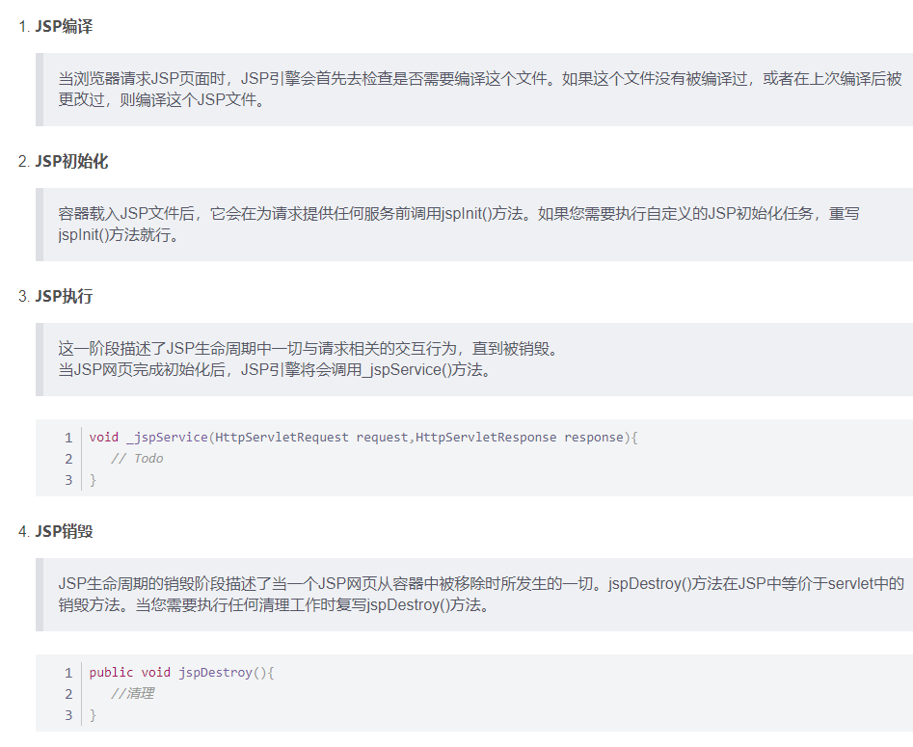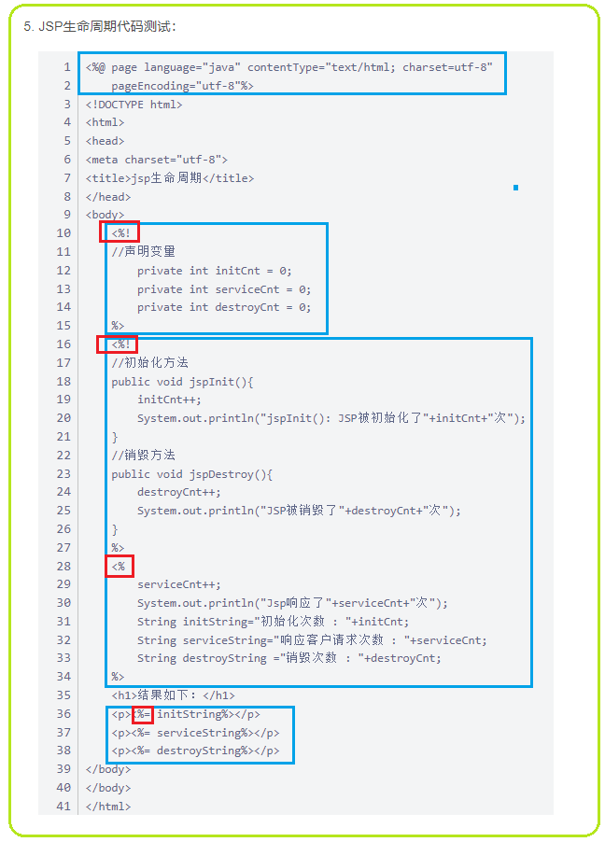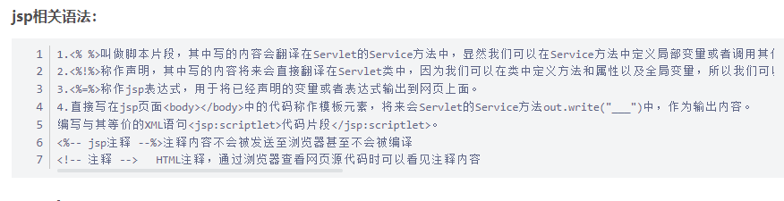 [https://blog.csdn.net/qq_40624026/article/details/113866531?ops_request_misc=%257B%2522request%255Fid%2522%253A%2522164870147316780264059085%2522%252C%2522scm%2522%253A%252220140713.130102334..%2522%257D&request_id=164870147316780264059085&biz_id=0&utm_medium=distribute.pc_search_result.none-task-blog-2~all~top_positive~default-2-113866531.142^v5^article_score_rank,143^v6^control&utm_term=Jsp&spm=1018.2226.3001.4187](https://blog.csdn.net/qq_40624026/article/details/113866531?ops_request_misc=%257B%2522request%255Fid%2522%253A%2522164870147316780264059085%2522%252C%2522scm%2522%253A%252220140713.130102334..%2522%257D&request_id=164870147316780264059085&biz_id=0&utm_medium=distribute.pc_search_result.none-task-blog-2~all~top_positive~default-2-113866531.142%5ev5%5earticle_score_rank,143%5ev6%5econtrol&utm_term=Jsp&spm=1018.2226.3001.4187)

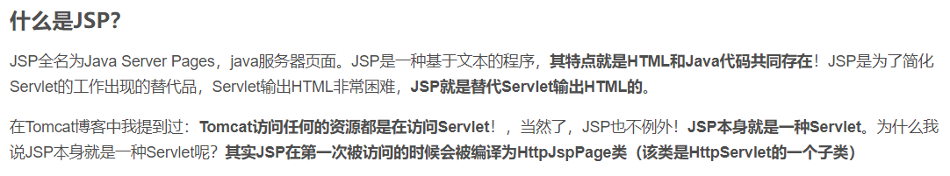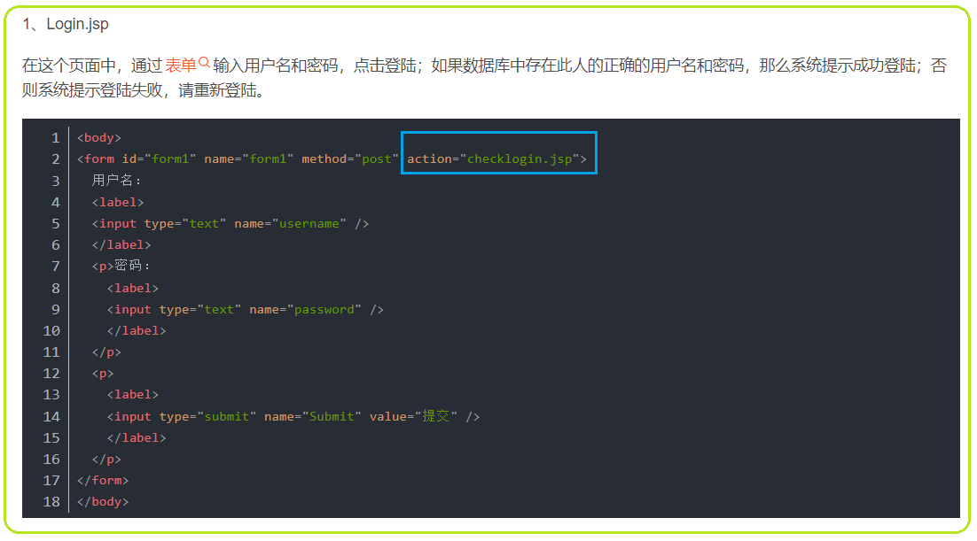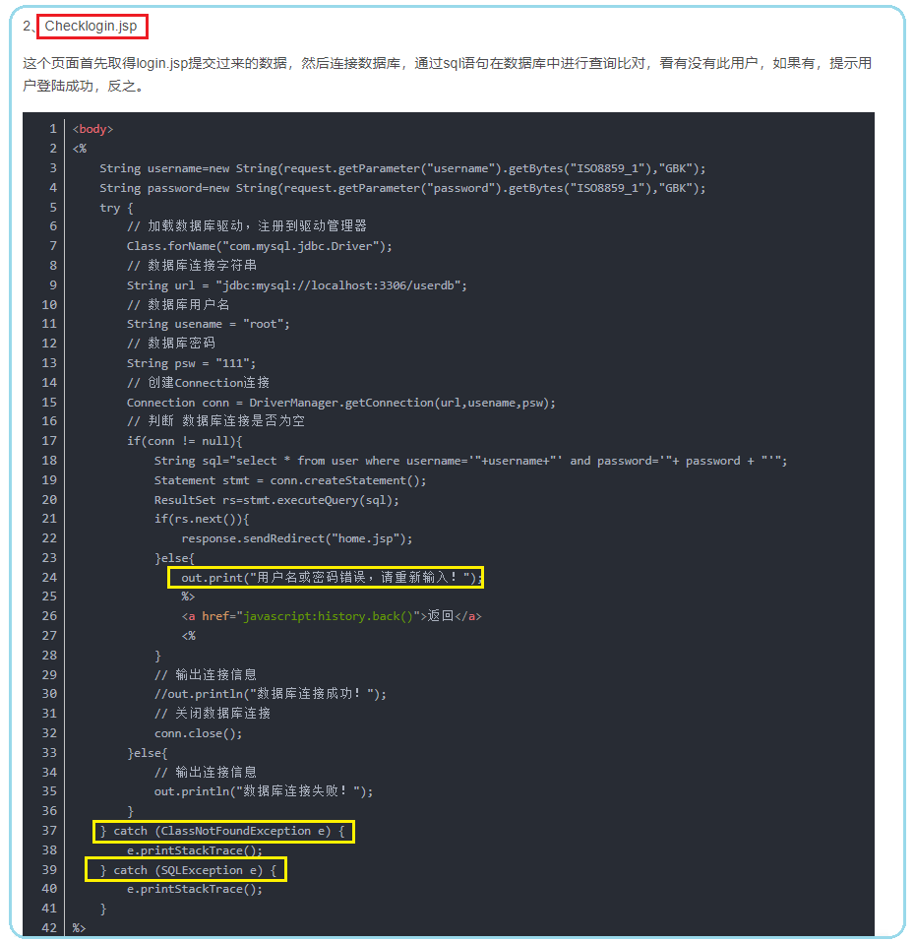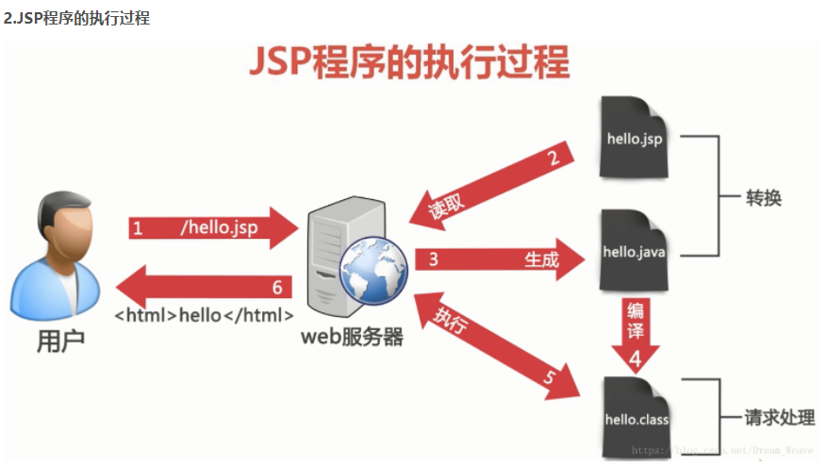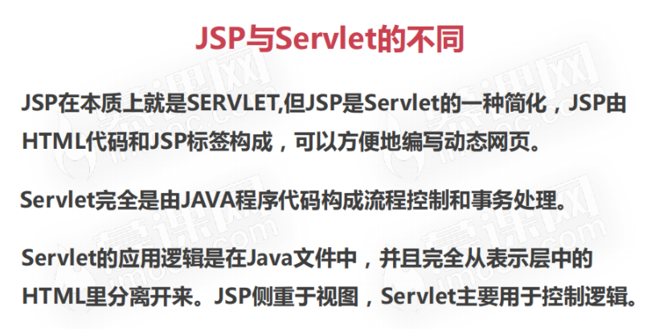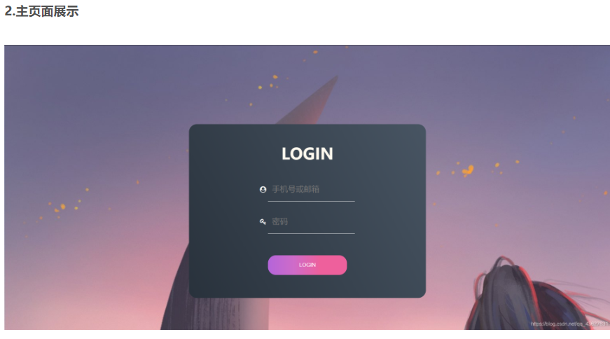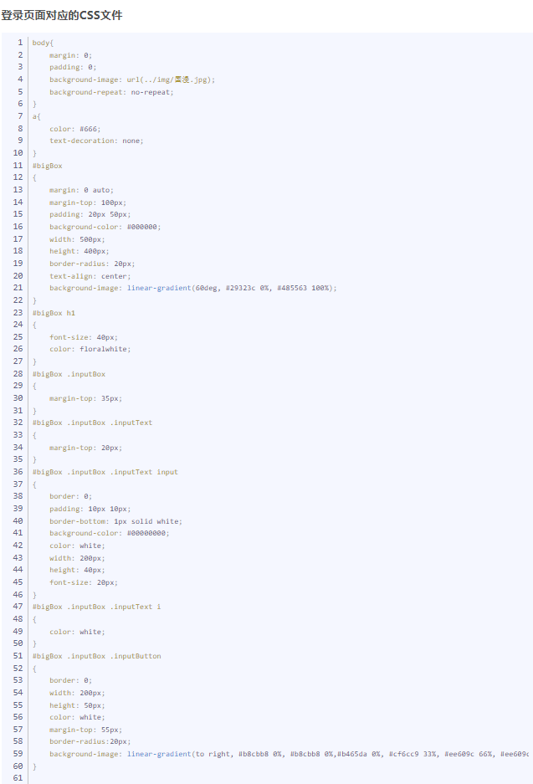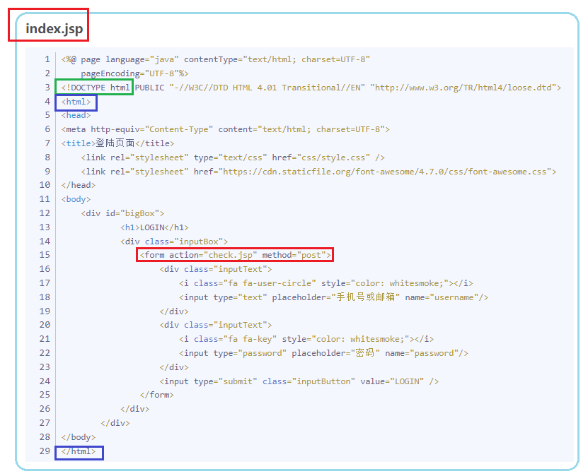

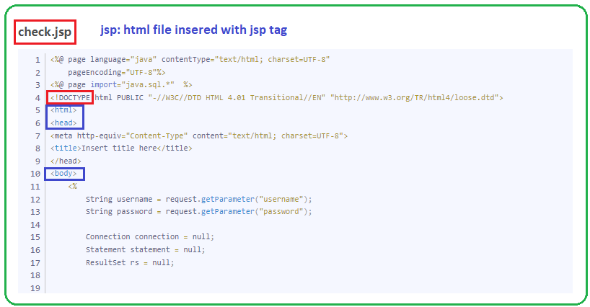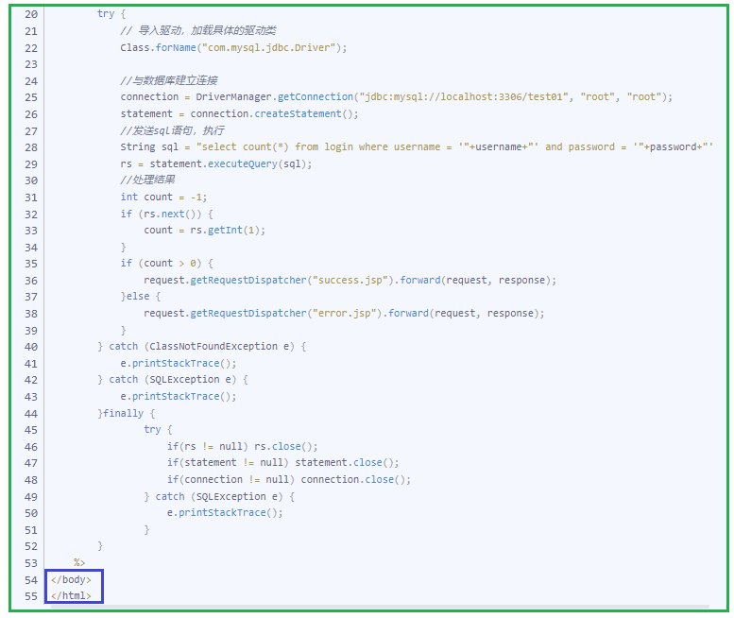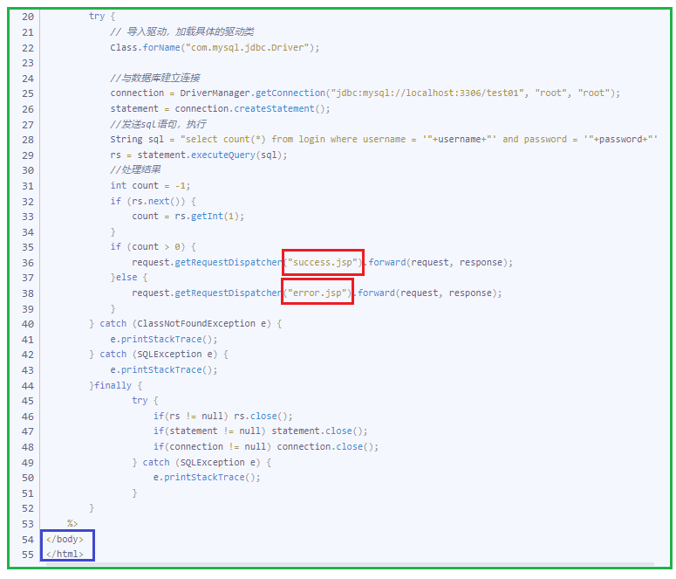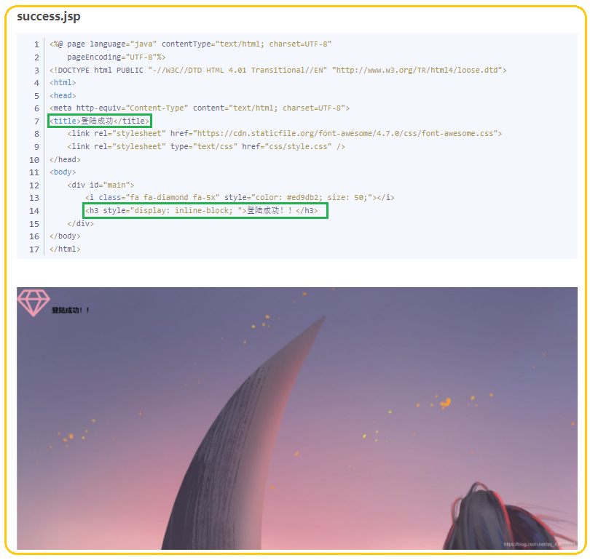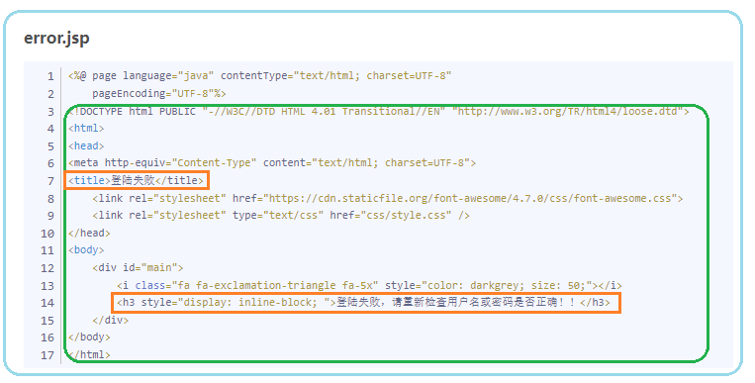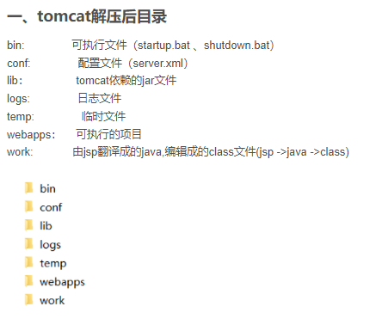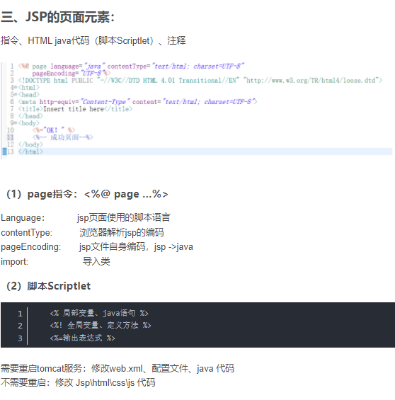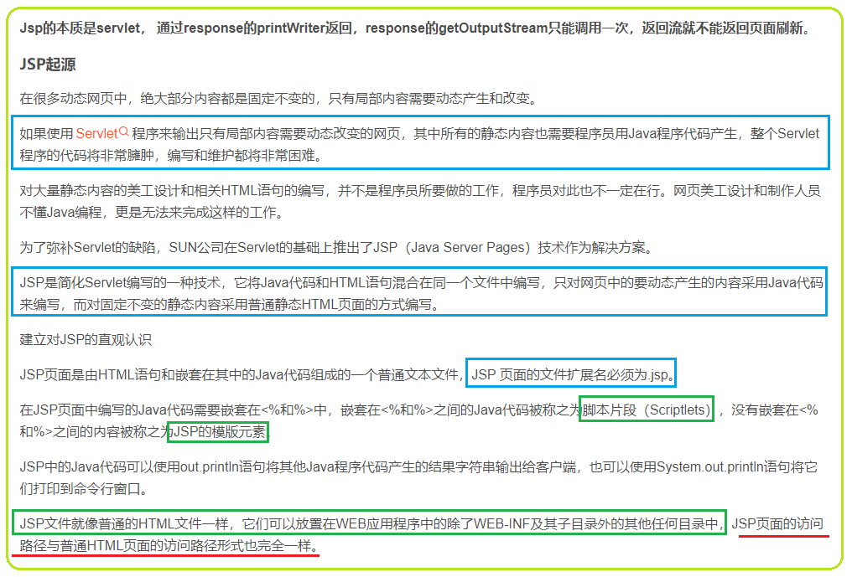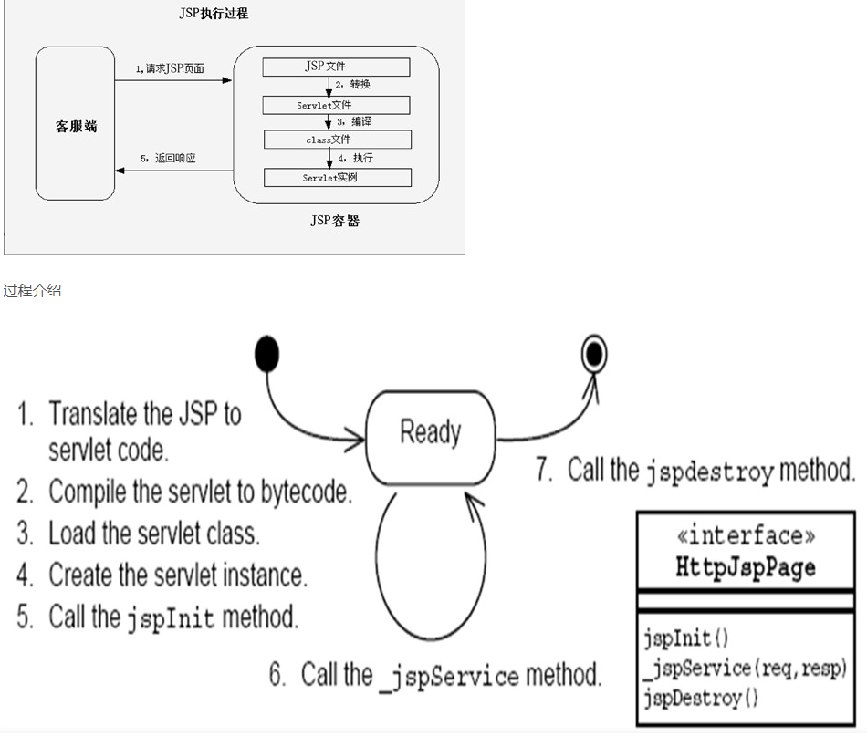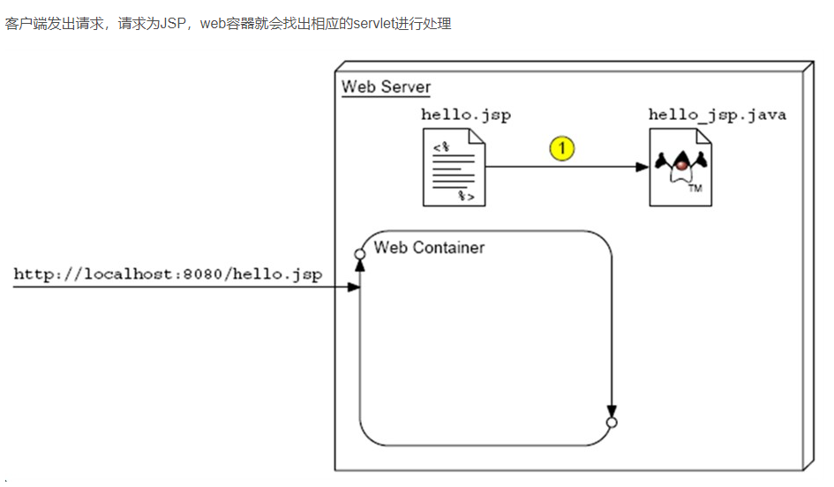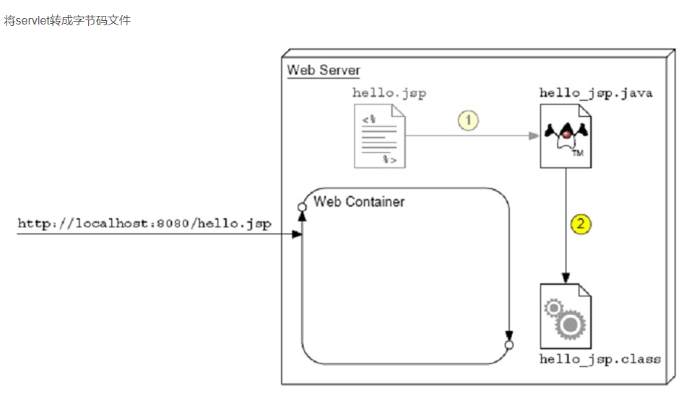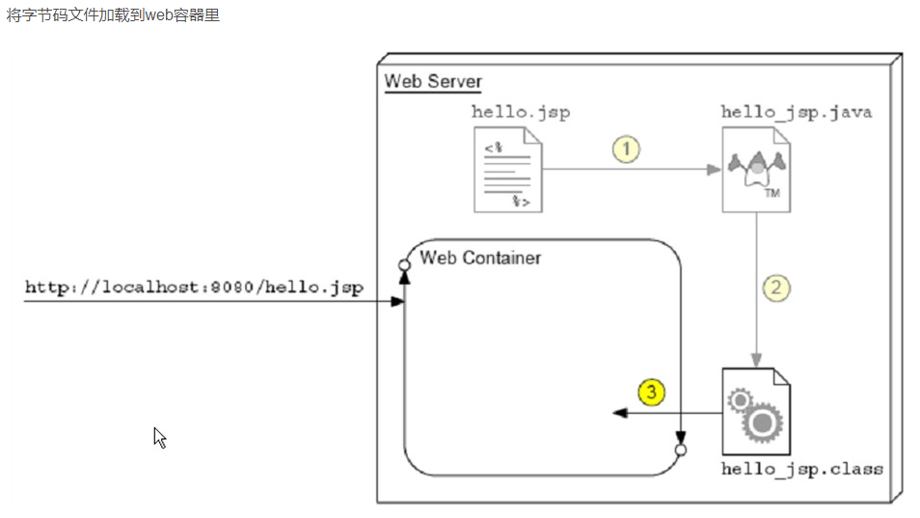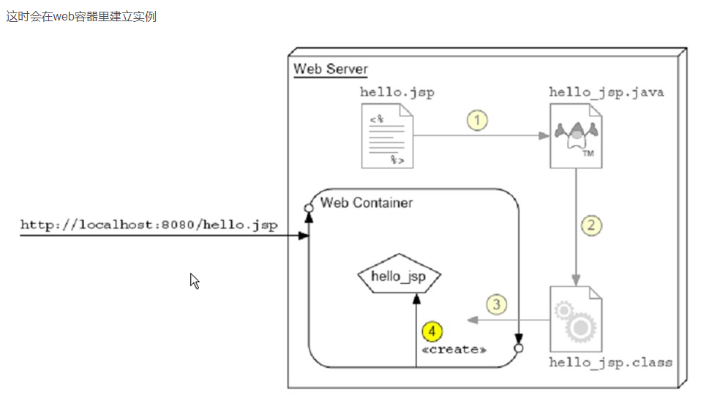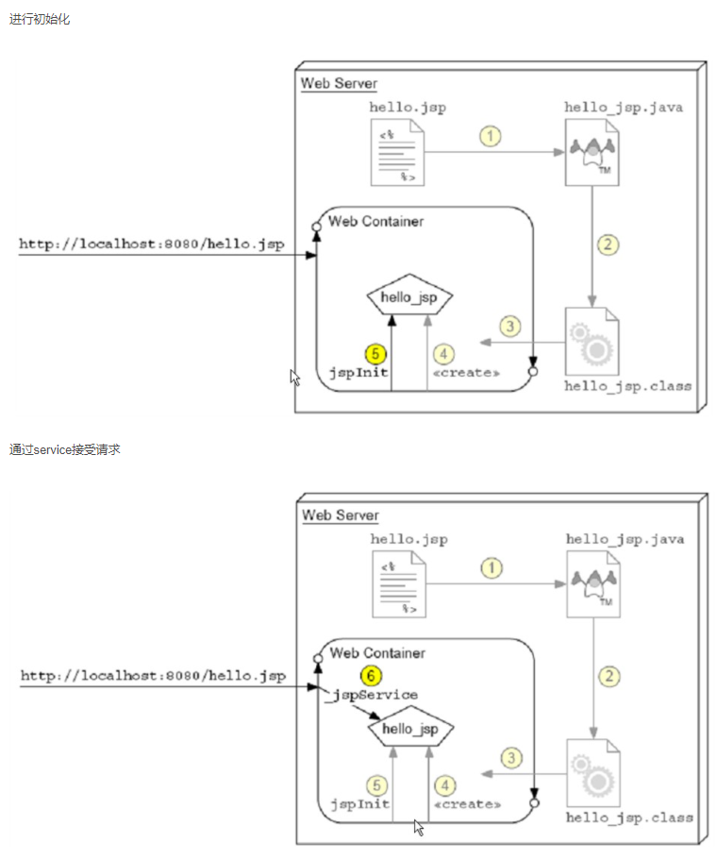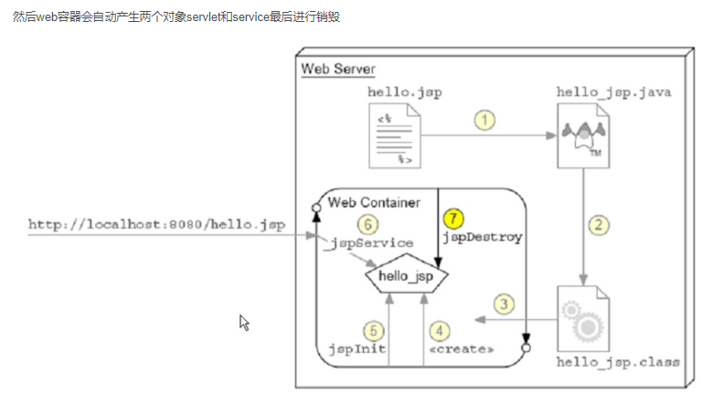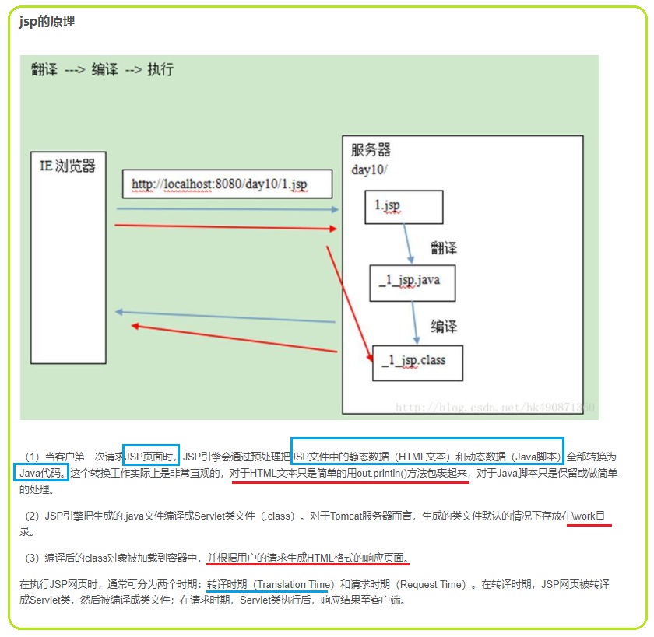

* **Js vs jsp**

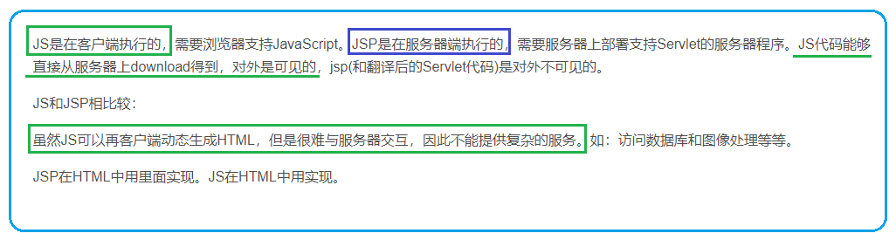

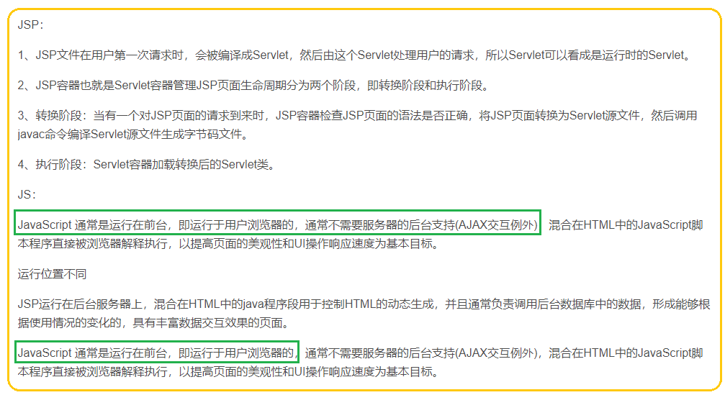

# ubuntu Linux Apache Tomcat环境搭建

# <https://so.csdn.net/so/search?spm=1001.2101.3001.4498&q=ubuntu%20Linux%20Apache%20Tomcat%E7%8E%AF%E5%A2%83%E6%90%AD%E5%BB%BA&t=&u=>

# [https://blog.csdn.net/weixin_41400063/article/details/105468525?ops_request_misc=&request_id=&biz_id=102&utm_term=Apache%20Tomcat&utm_medium=distribute.pc_search_result.none-task-blog-2~all~sobaiduweb~default-9-105468525.142^v5^article_score_rank,143^v6^control&spm=1018.2226.3001.4187](https://blog.csdn.net/weixin_41400063/article/details/105468525?ops_request_misc=&request_id=&biz_id=102&utm_term=Apache%20Tomcat&utm_medium=distribute.pc_search_result.none-task-blog-2~all~sobaiduweb~default-9-105468525.142%5ev5%5earticle_score_rank,143%5ev6%5econtrol&spm=1018.2226.3001.4187)

# 

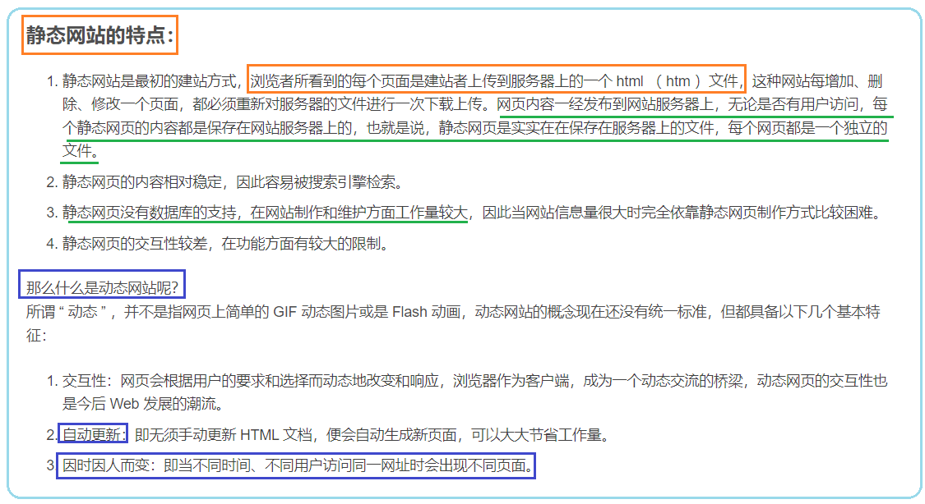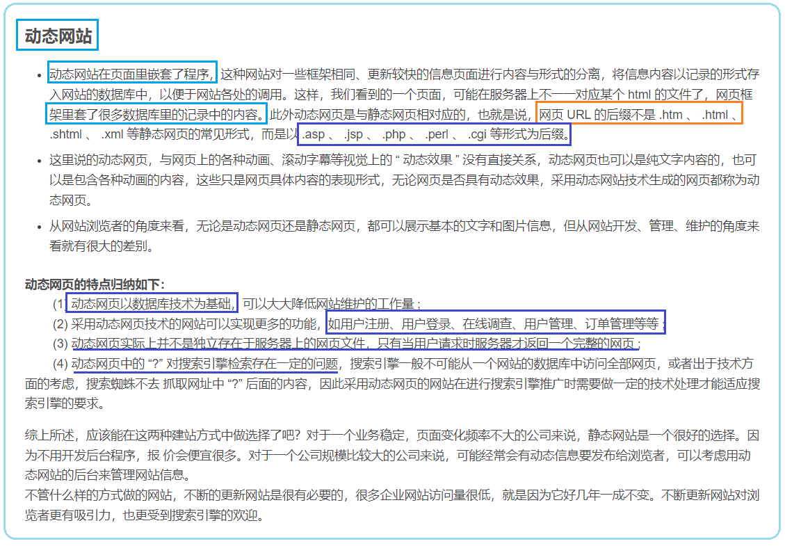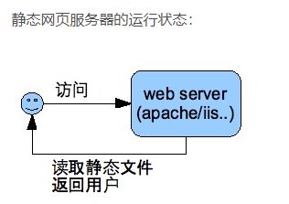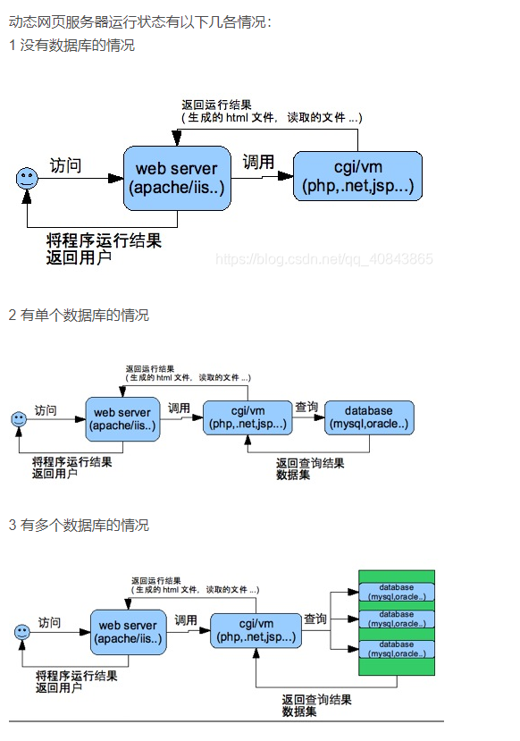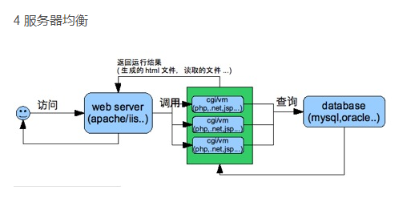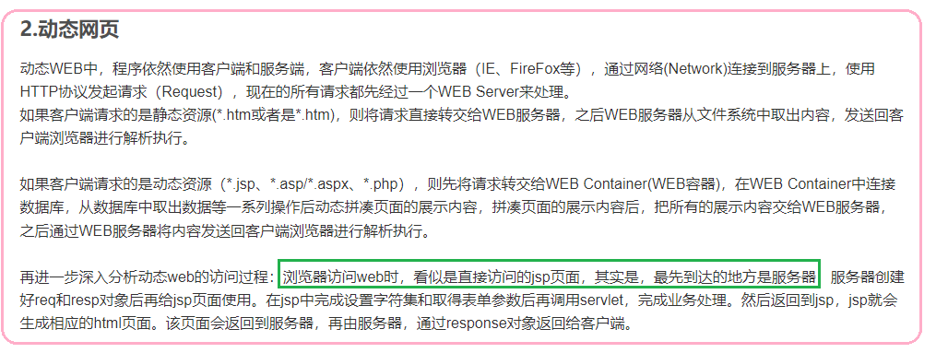

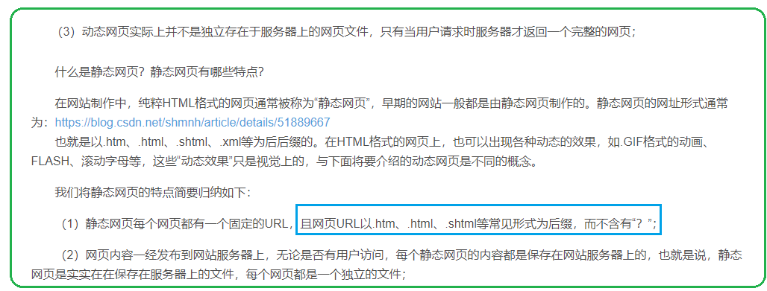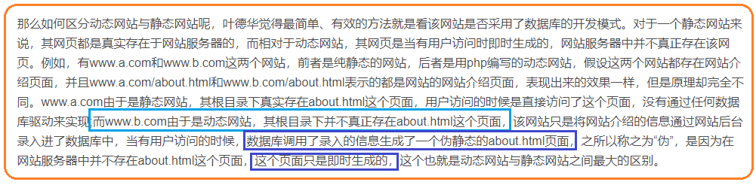

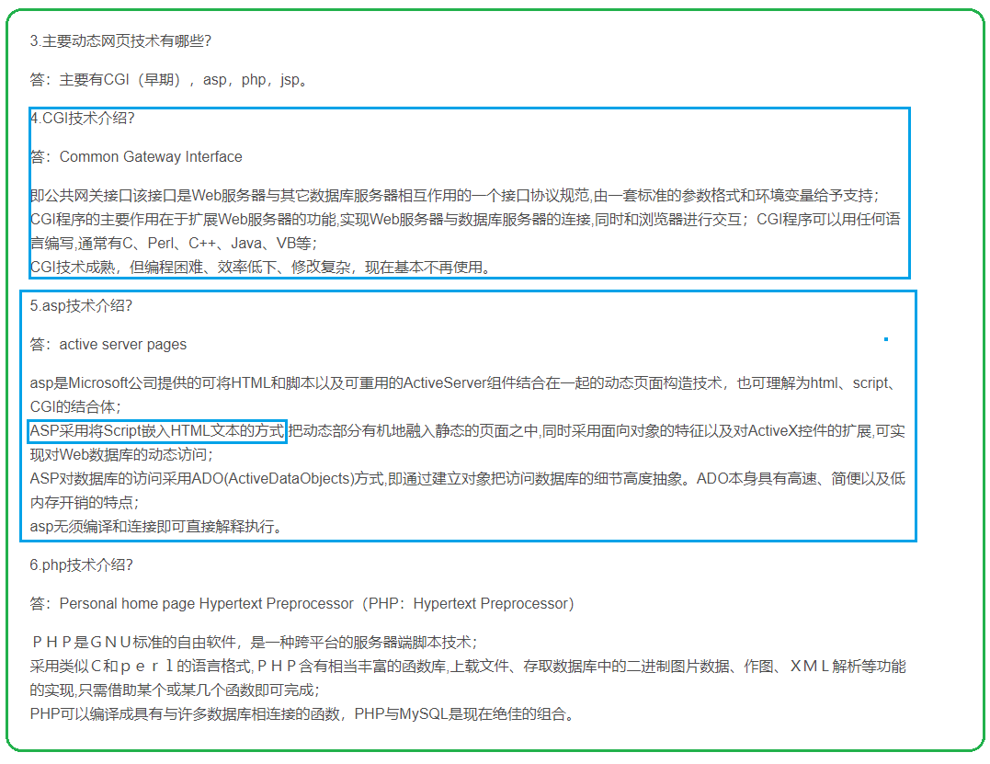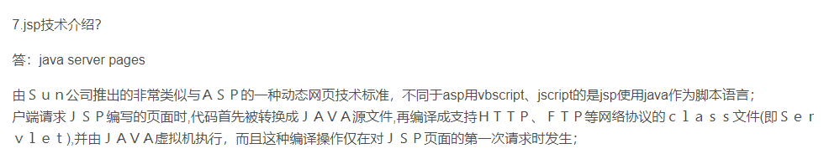

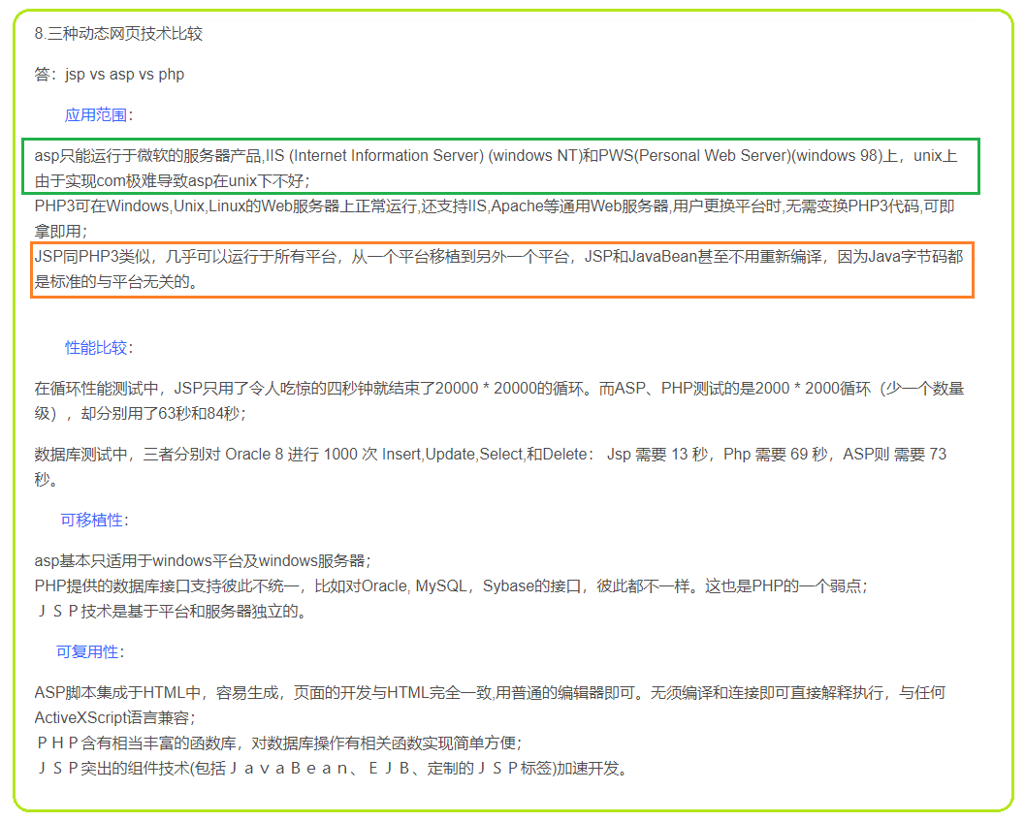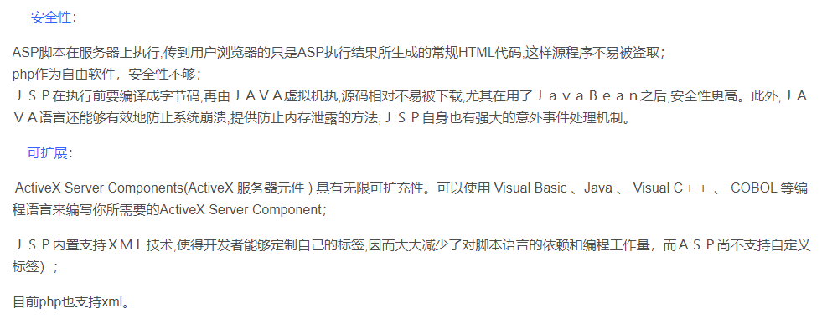

ASP、PHP、JSP、ASP.net、CGI

 一般以.asp、.jsp、.php、.perl、.cgi等形式为后缀